

English Curriculum Overview

Intent
At St Bede’s Catholic Primary School, we believe that all pupils should be able to confidently communicate their knowledge, ideas, and emotions through their writing. We want pupils to acquire a wide vocabulary, a solid understanding of grammar and be able to spell new words by effectively applying the spelling patterns and rules they learn across the Key Stages. We aim to support and guide them to write clearly, accurately, coherently, and creatively, adapting their language and style for a range of meaningful contexts, purposes, and audiences.

Handwriting, spelling and grammar will be explicitly taught to ensure that children are able to understand the conventions of writing and manipulate language to make it more effective for the reader.

We believe that all pupils should be encouraged to take pride in the presentation of their writing. From Year 2 onwards, children will learn to join letters effectively and will present their writing in a variety of ways and write for a variety of genres for both English lessons and the wider curriculum.

As they progress through school, the children of St Bede’s Catholic Primary School are immersed in a carefully planned range of genres through which they will build an understanding of:
- The purpose and audience for their writing,
- The intended impact of grammar and writing techniques,
- The effect vocabulary choice has on the readers’ thoughts and feelings and
- How to write effectively.

We set high expectations for our learners and challenge them to improve their writing as they move through a unit of work by providing clear feedback that supports the children to edit their content for quality. We want our learners to be thoughtful writers who have high expectations for themselves and take pride in their writing.

We expect our teachers to see writing as a process that requires responsive teaching and the ability to move backwards and forwards between different aspects of writing instruction rather than viewing this as a linear process. Our approach is represented using a spiral: teaching will move between different aspects, for example, following the teaching of vocabulary and a new grammar technique which incorporates this, the teaching may move on to practising this technique in a short burst writing task followed by revisiting and addressing any misconceptions or to develop and deepen understanding. Effective delivery of the curriculum requires teachers to feedback to children at all stages and use formative assessment to inform next steps in teaching.
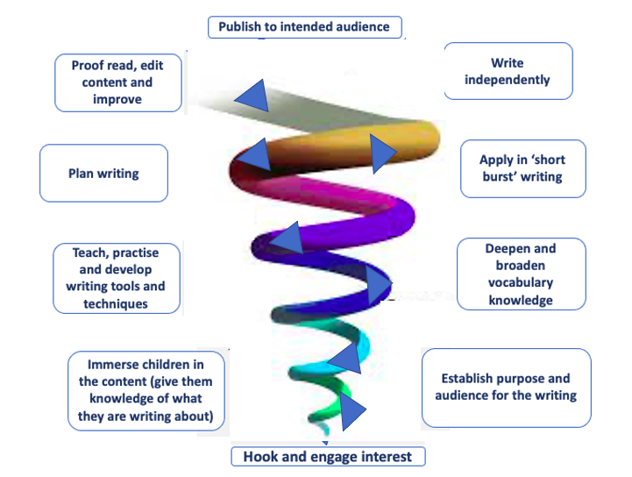

Implementation

At St Bede’s Catholic Primary School, we follow the Bishop Wilkinson Catholic Education Trust English curriculum which utilises high quality texts as the core text that acts as the stimulus for writing. The aim is for learners to explore the texts in a sustained way and engage with the materials in depth, thereby providing content for their own writing.

The curriculum provides teaching units from Nursery to Year 6 with a focus on 4 main pillars of learning:

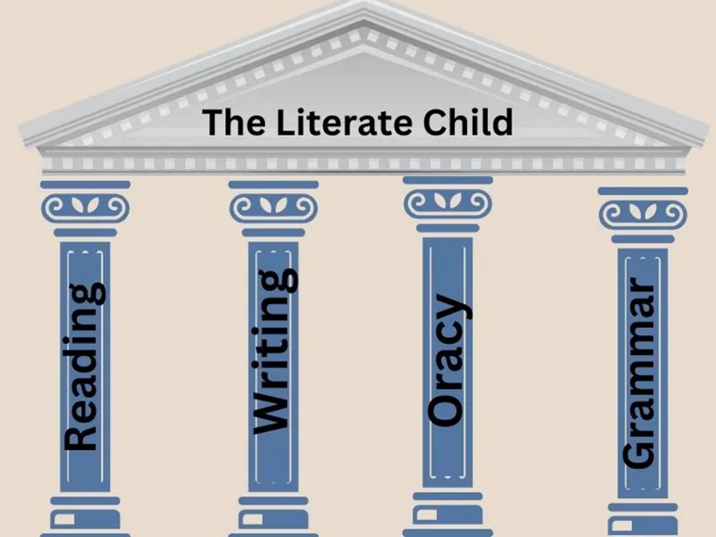

We believe that literacy is the foundation of learning and a vital life skill that empowers children to understand, express, and shape the world around them. Our curriculum is built upon four interconnected pillars—Reading, Writing, Grammar, and Oracy—each essential to helping every child become a confident, capable and thoughtful communicator.

Reading Pillar
Reading is at the heart of our literacy curriculum. We aim to develop fluent, enthusiastic readers who can decode accurately, comprehend deeply, and read for both pleasure and purpose. Through exposure to a wide range of high-quality texts, children build vocabulary, broaden their knowledge of the world, and develop empathy by seeing life through the eyes of others. Strong reading skills unlock learning across all subjects and nurture a lifelong love of books. (Appendix 1)

Writing Pillar
Writing enables children to communicate their ideas, experiences, and imagination with clarity and creativity. We teach children to write for a range of audiences and purposes, ensuring they understand how structure, vocabulary and style work together to create meaning. Through regular opportunities to plan, draft, edit, and publish their work, children learn to be reflective, precise, and confident writers who take pride in their voice. (Appendix 2)

Grammar Pillar
Grammar provides children with the tools they need to use language accurately and effectively. By developing strong grammatical knowledge, children can construct sentences that are clear, coherent, and purposeful. Understanding how language works not only strengthens writing but also enhances reading comprehension and spoken communication. We teach grammar in meaningful contexts so that children can apply their learning with confidence and independence. (Appendix 3)

Oracy Pillar
Oracy—the ability to communicate through spoken language—is a vital pillar of our curriculum because speaking and listening underpin all literacy development. Through structured talk, discussion, performance, debate, and collaborative learning, children learn to articulate ideas clearly, listen respectfully, reason effectively, and build positive relationships. Strong oracy skills support problem-solving, deepen understanding, and help children thrive socially and academically. (Appendix 4)
Together, these four pillars create a rich, balanced and ambitious approach to literacy. They equip children with the skills to read widely, write confidently, speak clearly, and understand how language works. By developing literacy in this holistic way, we ensure that every child leaves primary school with the knowledge, confidence, and communication skills needed to flourish in the next stage of their education and throughout their lives.
Each unit of work lasts between 2-3 weeks and is delivered through four 1-hour English lessons per week. The teaching sequence for each unit is detailed in our medium-term plans. These are divided into steps which may equate to one or more lessons and are dependent upon the needs of a particular class or group. We expect teaching and planning to be responsive, for example, if more than one lesson is needed to embed a skill, then this should be done before moving on to the next step to ensure that there are no gaps in learning.
At St Bede’s, the English curriculum is carefully structured from Nursery to Year 6 to ensure a coherent, progressive, and ambitious journey in language and literacy. Our planning and teaching are underpinned by the belief that every child can become a confident reader, writer, speaker, and thinker when provided with high-quality teaching and purposeful learning experiences.
The English curriculum is organised into 2–3-week teaching units across all year groups. This structure allows children to explore texts in depth, develop key skills systematically, and apply their learning in meaningful contexts. English lessons take place four times per week, ensuring regular, consistent engagement with reading, writing, grammar, and oracy.
Our curriculum is deliberately designed as a stepped progression, where knowledge and skills build incrementally over time. Teachers use ongoing assessment to respond to pupils’ needs, ensuring that learning is adapted, reinforced, or extended as appropriate. This responsive approach supports all children in moving through the curriculum securely and confidently.
Detailed long- and medium-term plans frame the learning journey in English and ensure clear progression from early language development in the Early Years to sophisticated literacy in Year 6. Planning is centred around the four pillars of our English curriculum. These pillars work together to build a broad, balanced, and ambitious experience of English language and literature for every child.
High-quality texts sit at the heart of every unit. Texts are chosen to:
- Increase in challenge throughout the year and across year groups
- Align with Lexile measures to ensure appropriate levels of stretch and support
- Provide a balanced and diverse reading diet, representing a range of cultures, voices, genres, and historical periods
- Inspire curiosity, imagination, and rich classroom discussion
This approach supports children in developing reading fluency, comprehension, vocabulary, and critical thinking while also cultivating a genuine love of reading.
Through structured, responsive teaching; high-quality planning; and rich, carefully curated texts, our English curriculum supports every child to become a confident, articulate, and literate learner. We are committed to ensuring that all pupils leave primary school equipped with the skills, knowledge, and enthusiasm they need for future academic success and lifelong engagement with language.
Each year group has a ‘Literary Canon’ of core texts that are studied across the year.

Nursery
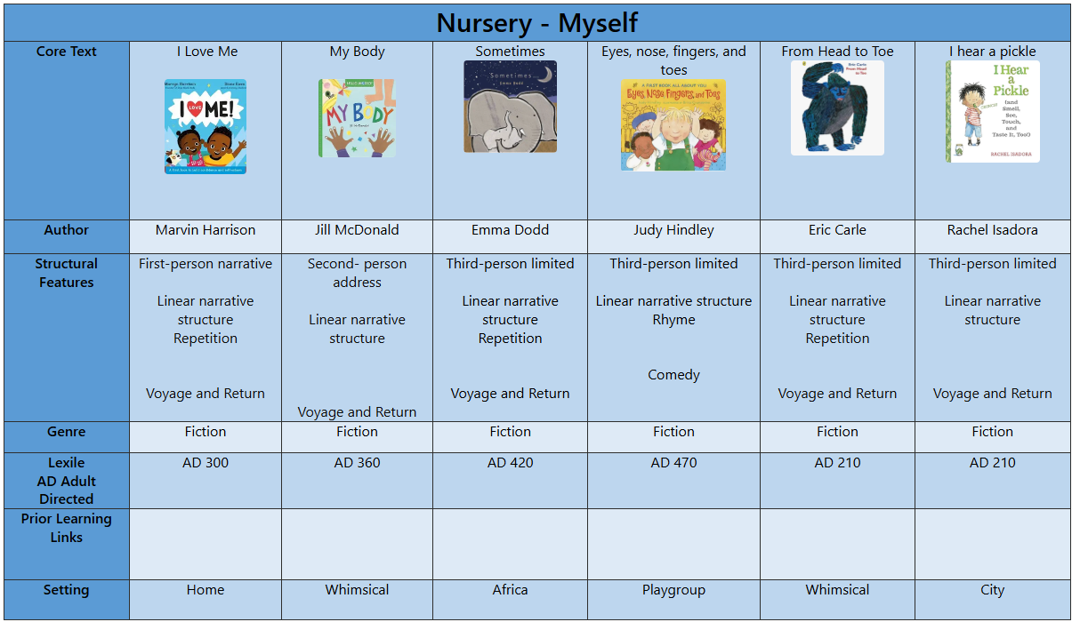

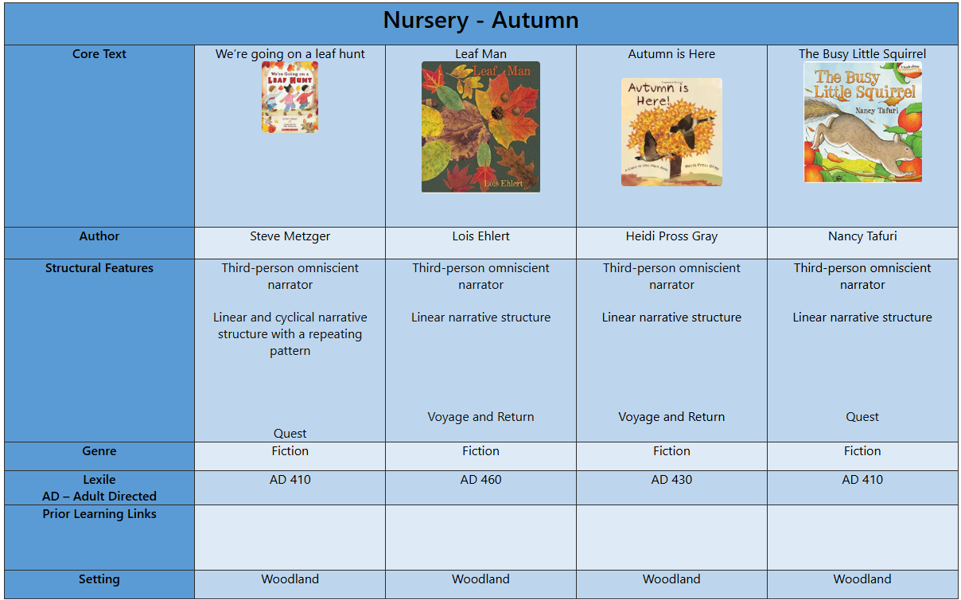

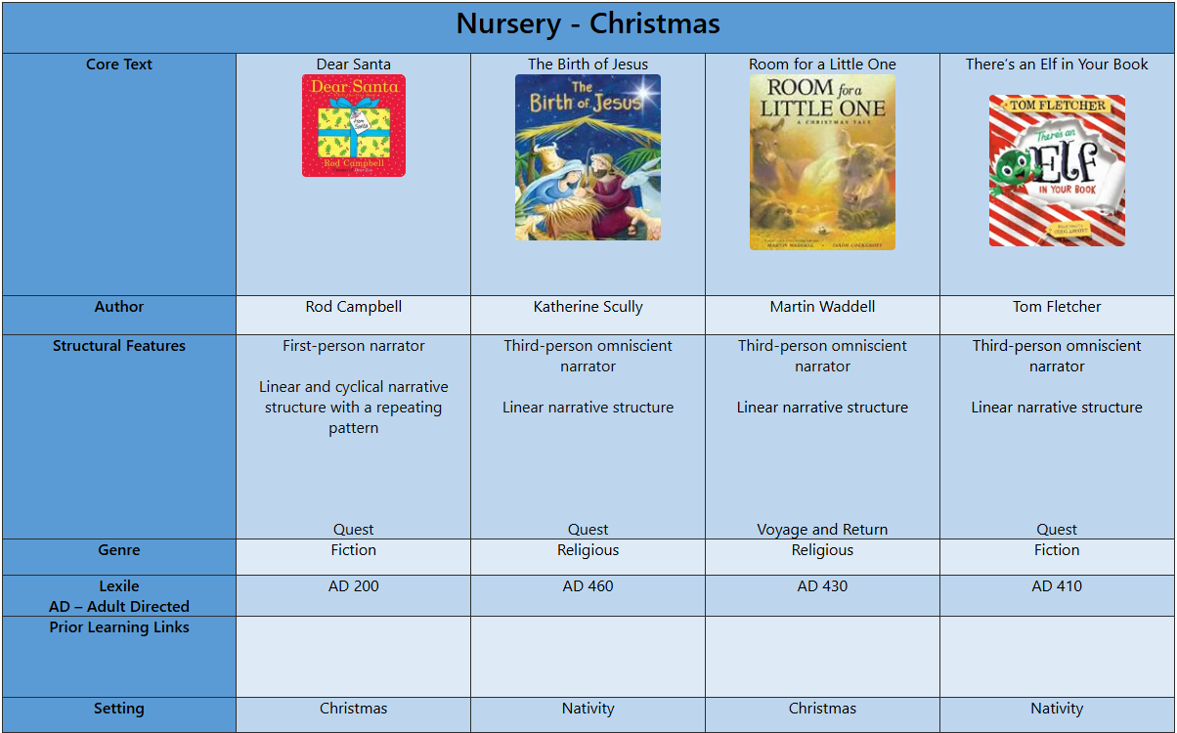

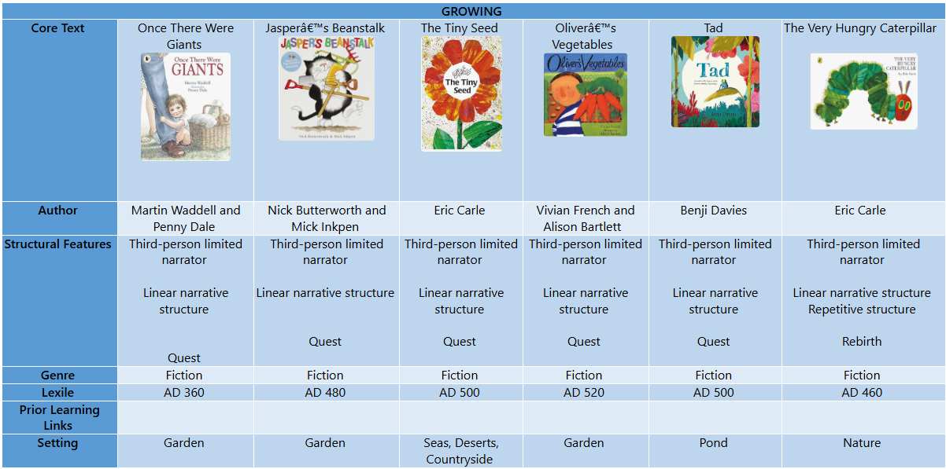

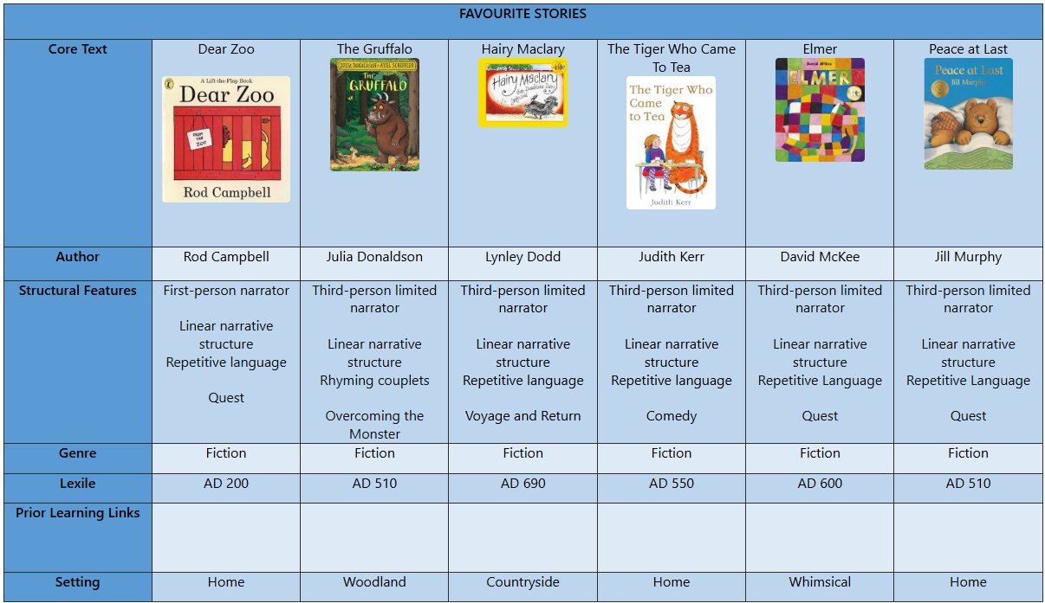

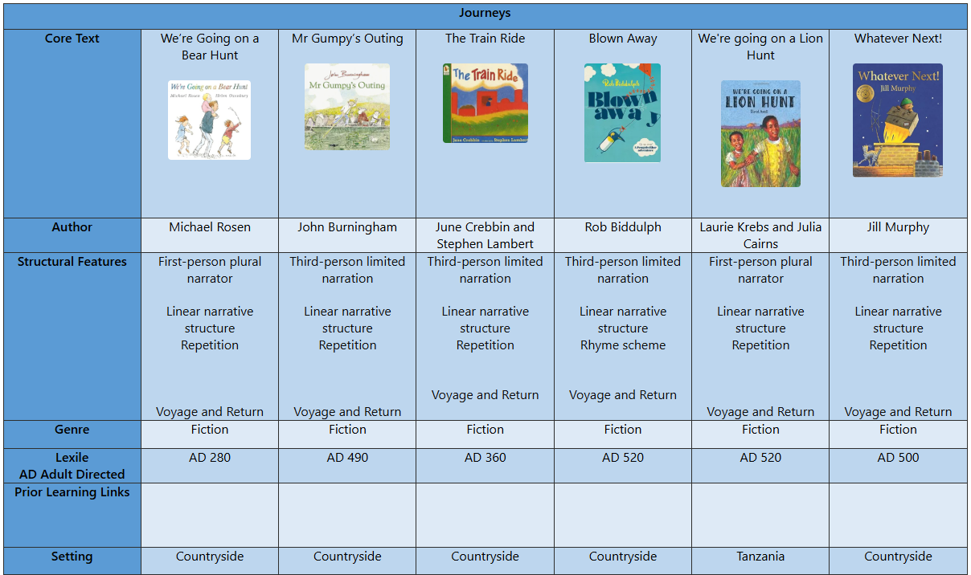

Reception
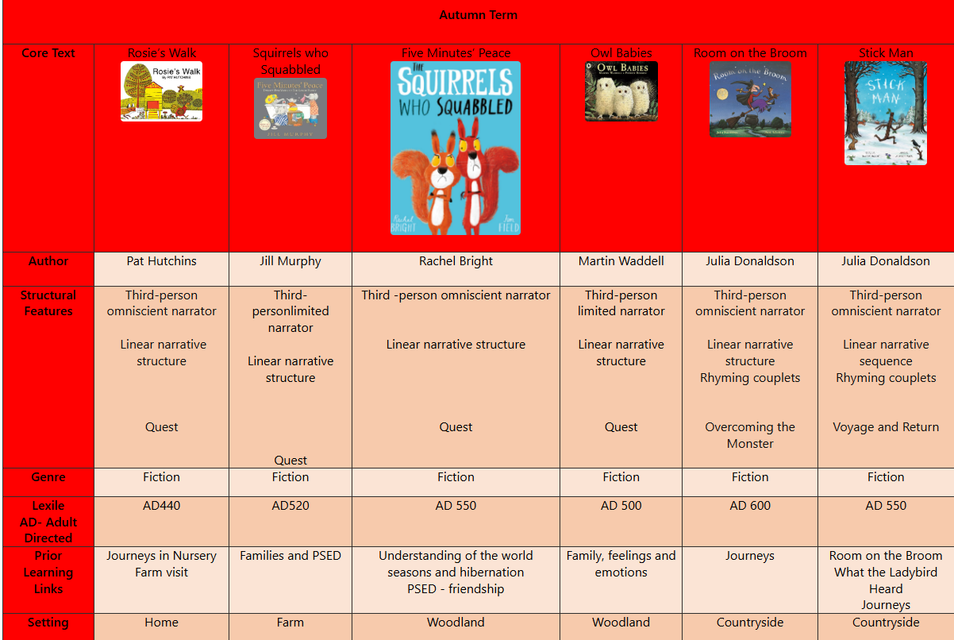
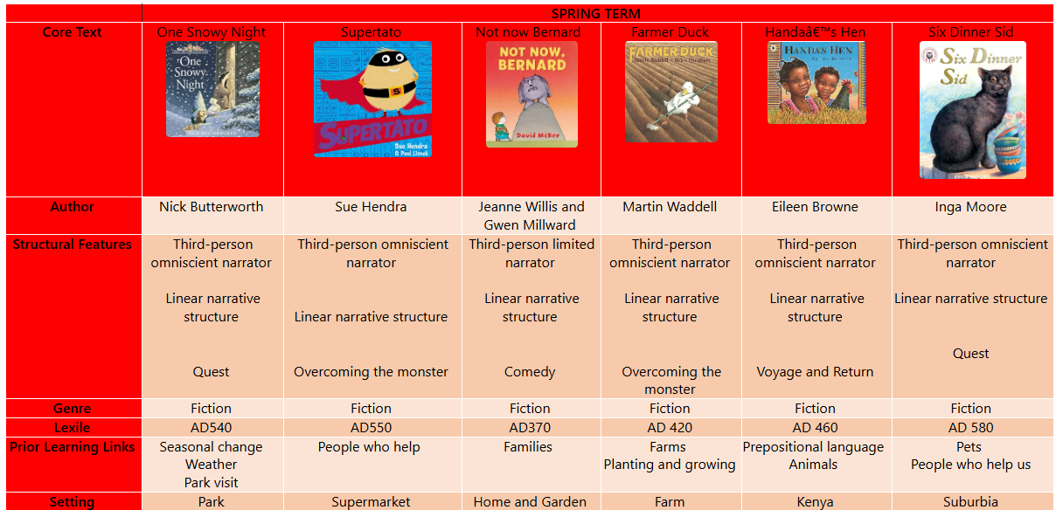

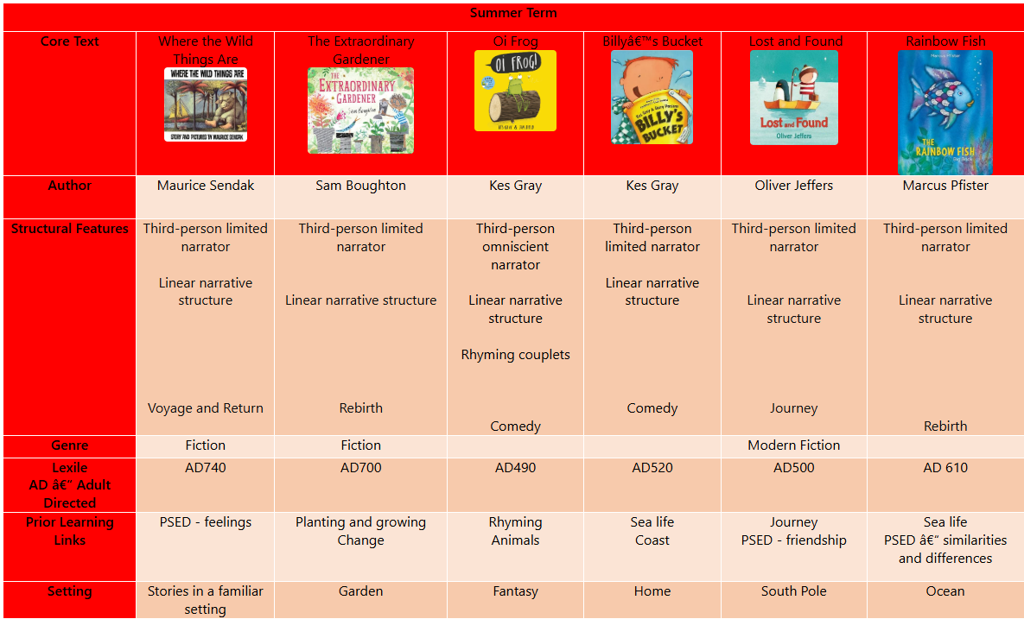

Year 1
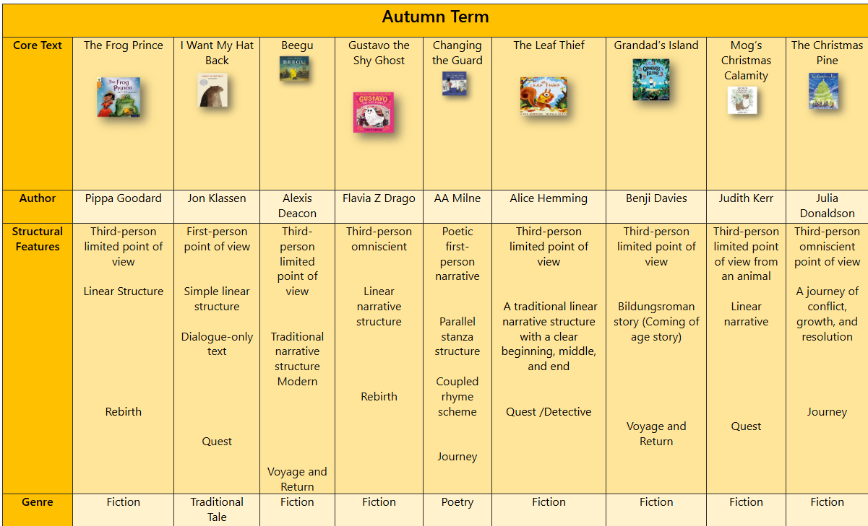
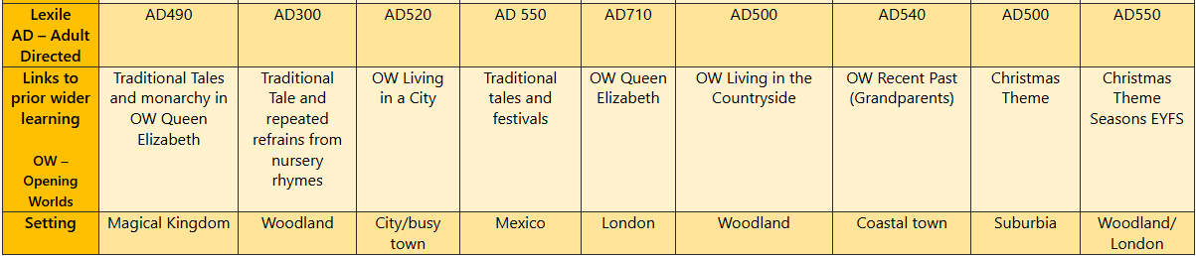
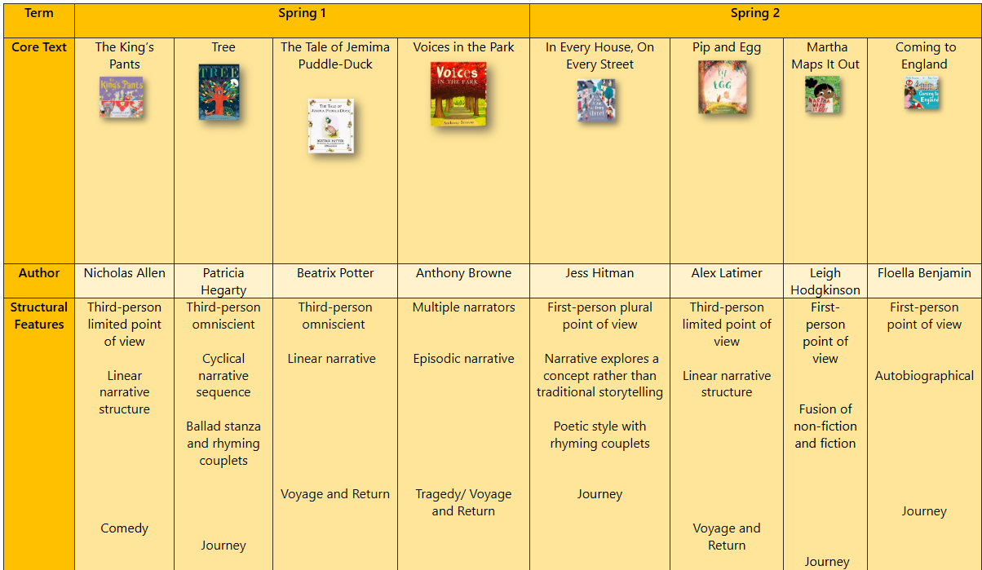
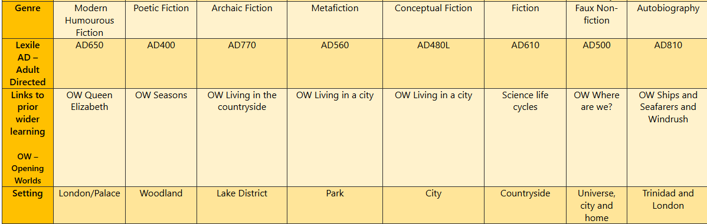
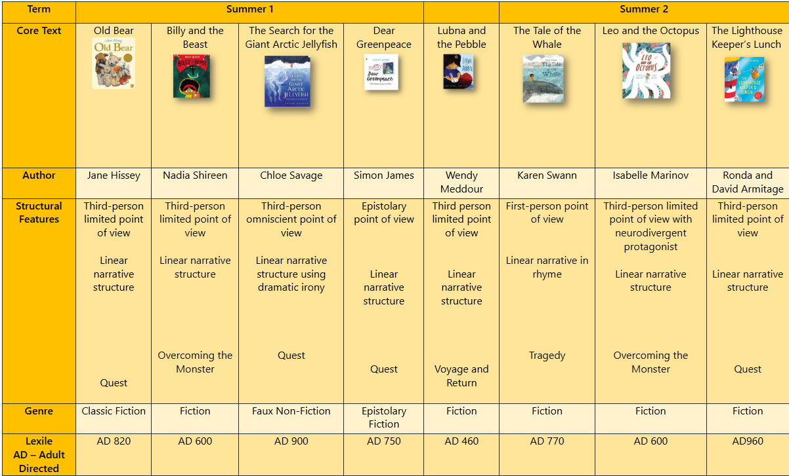
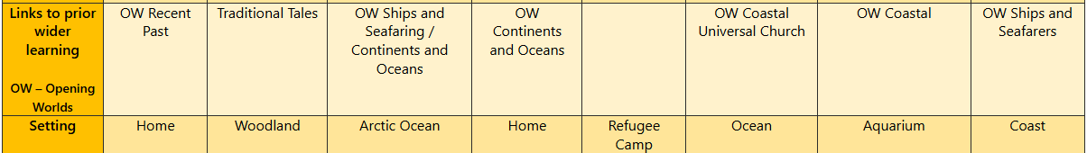

Year 2
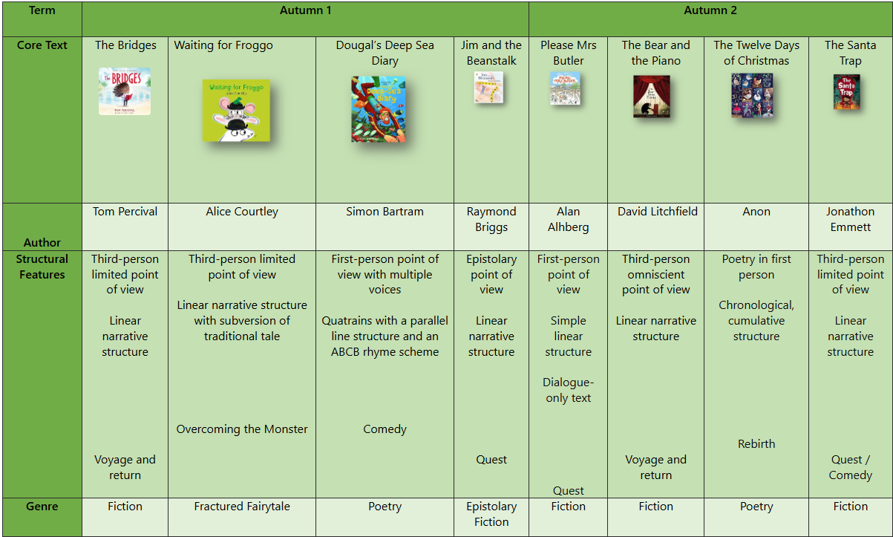
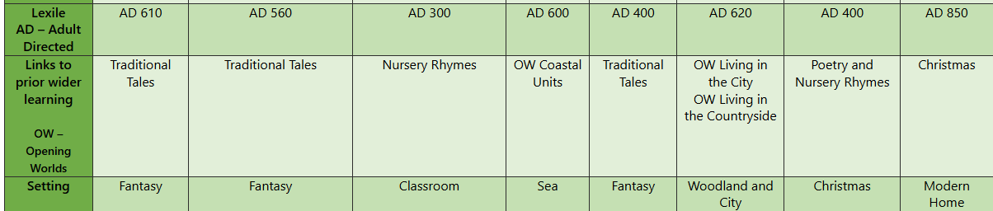
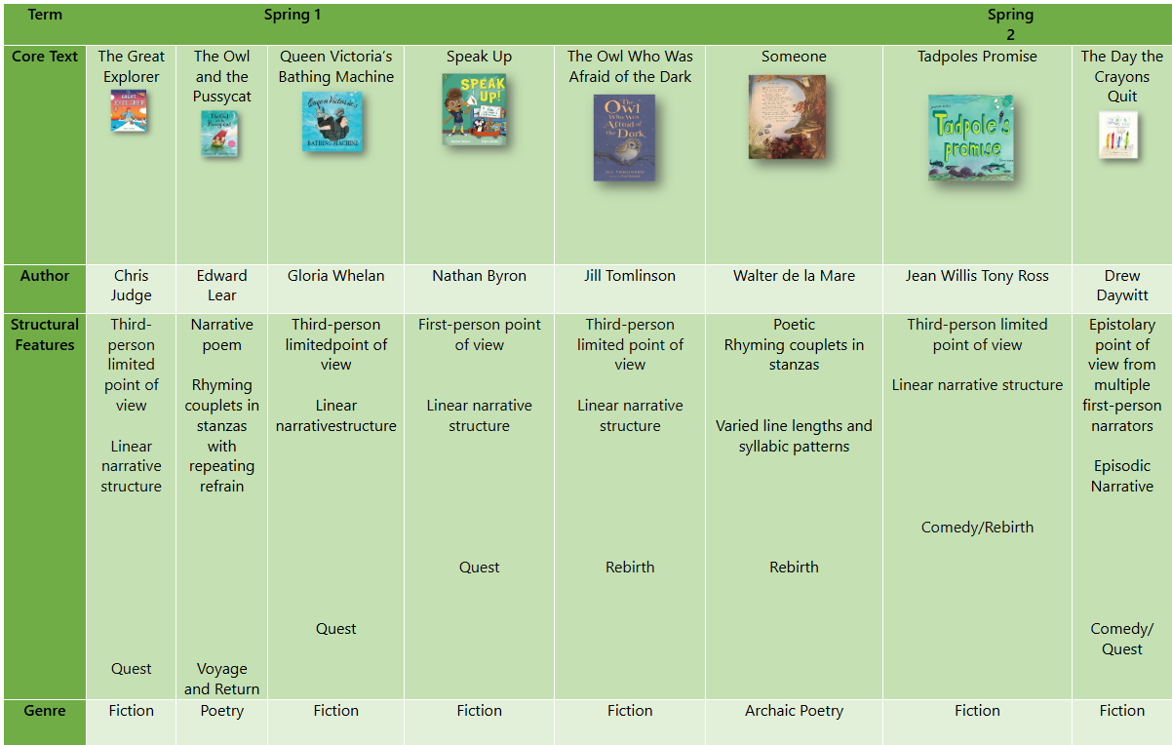
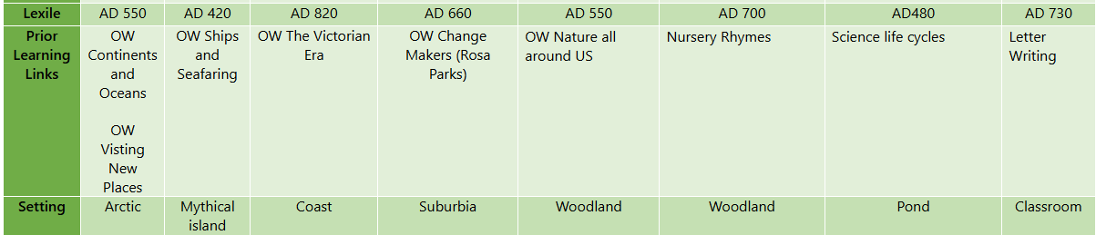
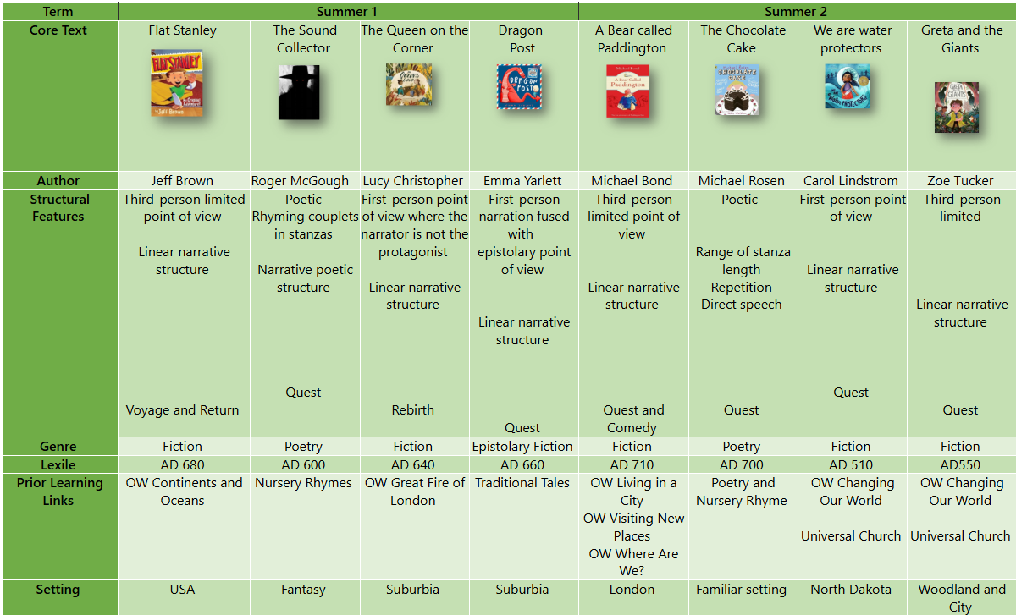

Year 3
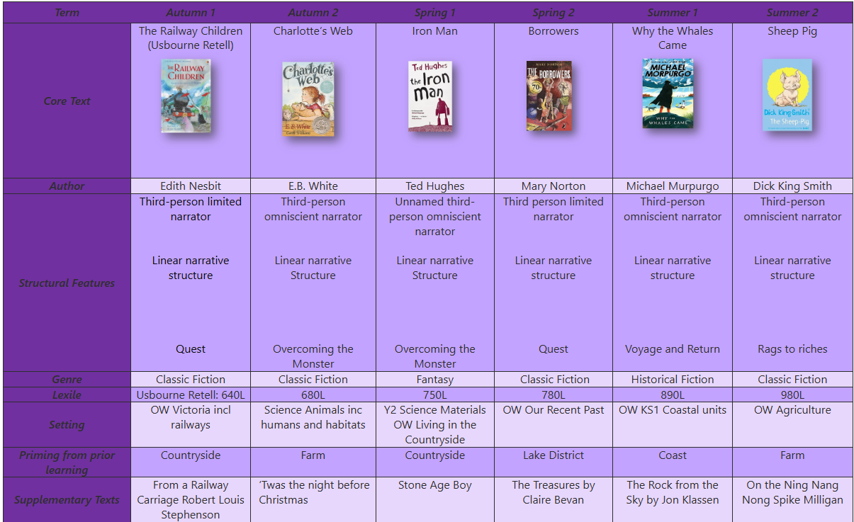

Year 4
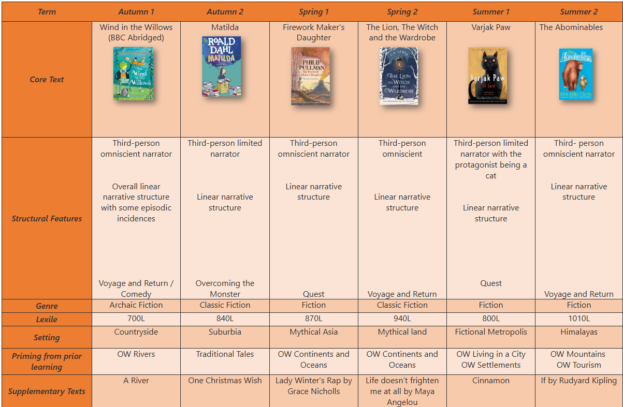

Year 5

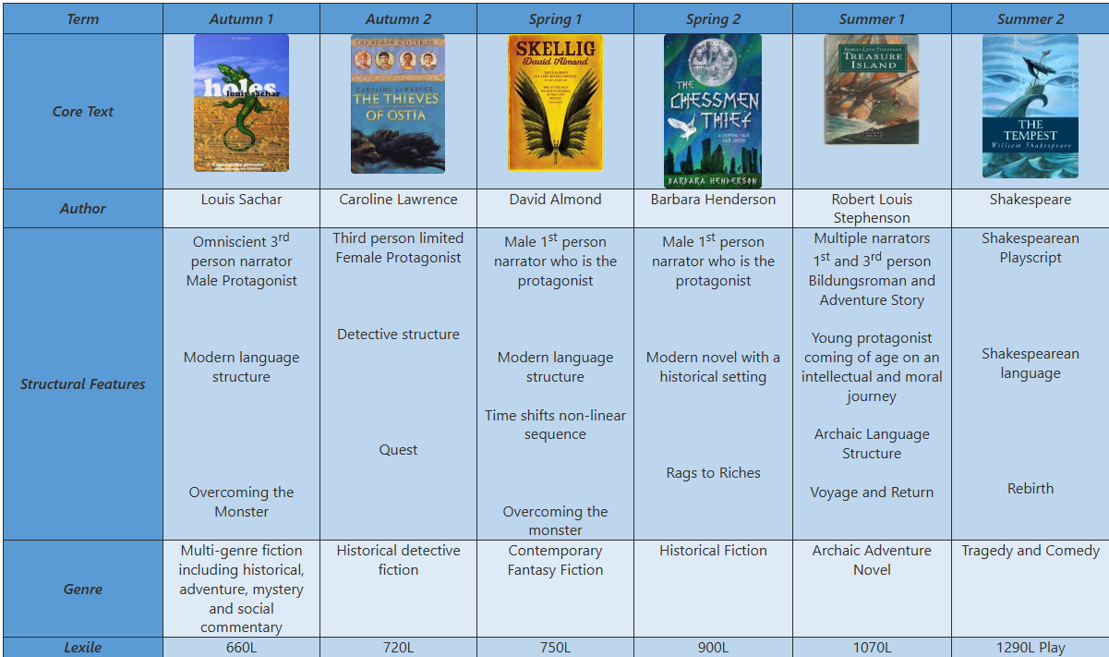
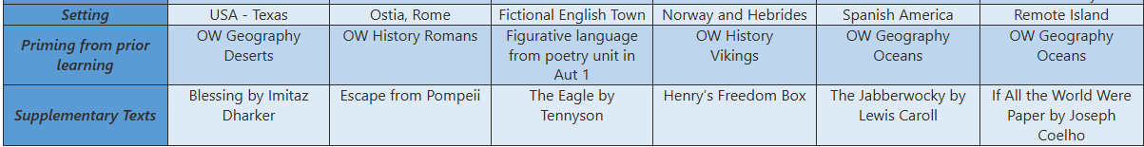
Year 6
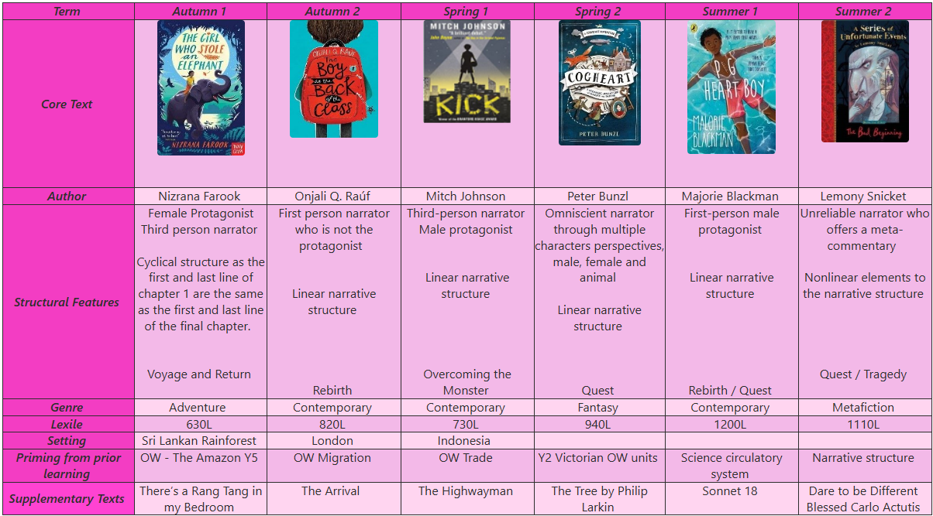

In addition to these texts, EYFS and Year 1 have additional Poetry and Traditional Tales canons, which are read regularly across the week. These are texts that are made available to the children during independent reading or are poems and rhymes which the children learn by heart.

EYFS Rhyme Canon
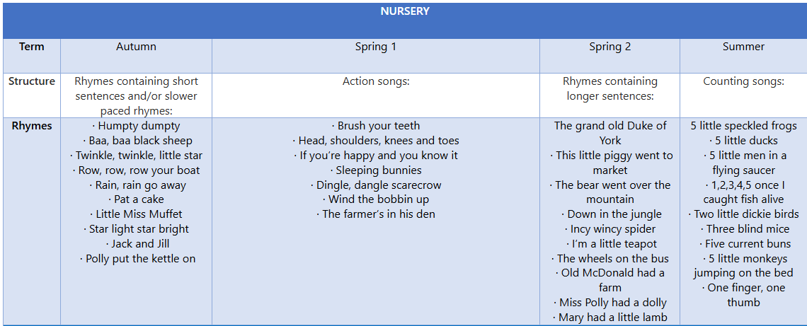
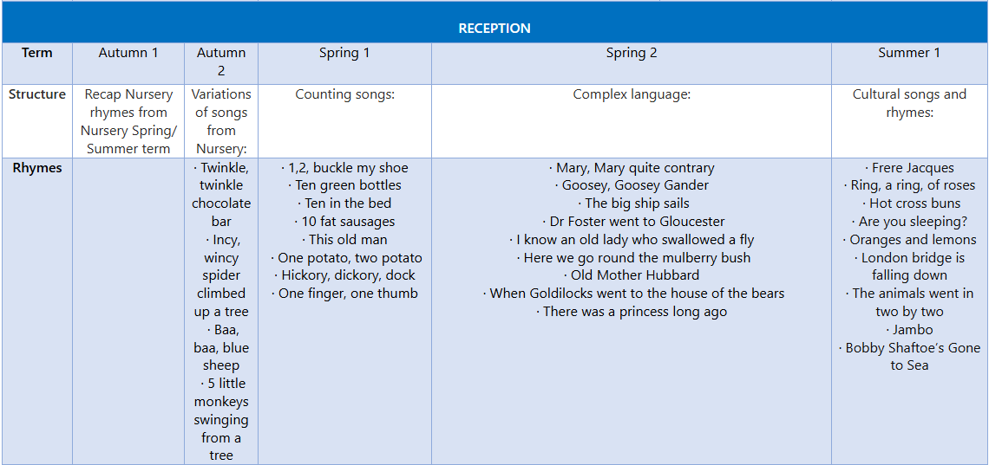

EYFS Traditional Tales Canon
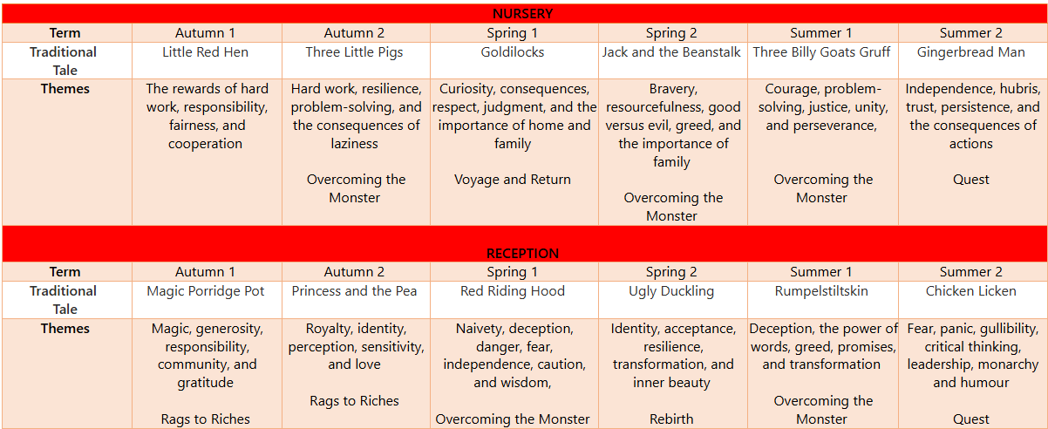

Year 1 Poetry Canon
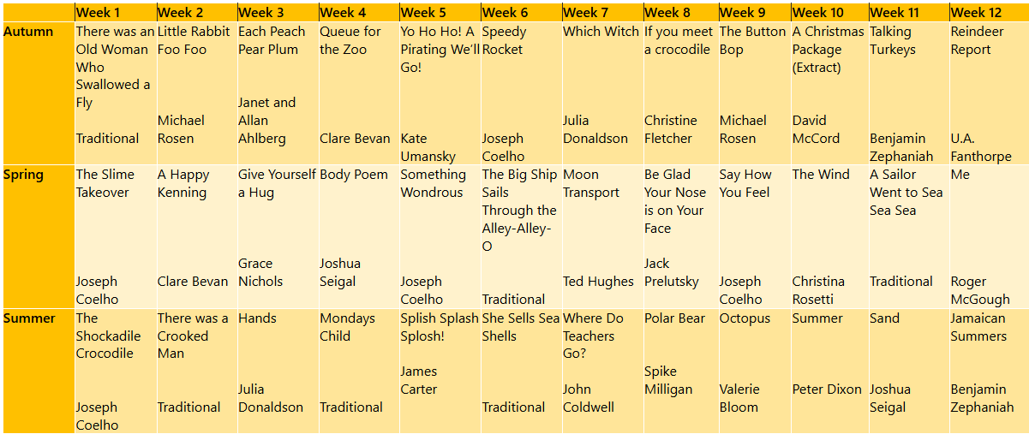

Teaching Sequence

Hook
Each unit of work begins with a hook into the core text. This may include an object to discuss, a scene to explore or questions to stimulate discussion. Subsequent steps help to build the children’s knowledge and understanding of the core text. These can be revisited or extended during the unit, according to the needs of the pupils.

Each lesson from Y1-6 will include retrieval practise based on prior learning (key questions that centre on learning from past years, terms or weeks) and dictation passages that aim to improve fluency in handwriting and spelling. Key elements of grammar and punctuation are taught within the units so that the children can explore these concepts within their reading and writing in context. The key focus of this curriculum is to craft and embed the formulation of effective sentences, using appropriate grammar, punctuation and spelling, so that the children can write with fluency, accuracy and cohesion, thus lowering their cognitive load, so that they can develop their own creative writer’s voice.

Immersion in Content
During this phase of teaching, the aim is for children to gain content for their writing. This will involve in-depth discussion and exploration of the core mentor text of the unit. Teachers plan tasks, activities and approaches in this phase depending on the written outcome of the unit e.g., if the written outcome is a character description, tasks in the immersion phase will focus on getting to know the character really well; if the written outcome is a discussion, the immersion phase will focus on understanding differing viewpoints of a situation; and if the written outcome is a non-chronological report, the immersion phase will focus on understanding and learning facts, ideas and information that can be used in a report.

Key approaches in this phase will include:
- Reading and re-reading the text
  - We expect teachers to model fluent and expressive reading to the children by reading aloud. When reading to the children we are teaching fluency: changing voice, pace, intonation etc.
  - Teachers will build in regular opportunities for echo and choral reading so that children can practise these skills for themselves.
  - Throughout the immersion stage, children will be given opportunities to read and re-read the text (in short sections) for themselves to build understanding and confidence in the content for their own writing.

Modelled reading | Echo reading | Choral reading | Repeated reading
Adults should read to children to show what fluent reading sounds like. The reading should be natural with the right tone, pace, and emotion to match the words read.  By listening to good models of fluent reading, children learn how a reader’s voice can help the text make sense. | First model how to read a sentence with good phrasing, intonation, and expression.  Then, ask the children to echo back and imitate the good phrasing, intonation, and expression. | Teacher and children read together at the teacher’s pace.  The teacher explicitly models the skills of proficient reading, including reading with fluency and expression. | Fluency gets better the more children read and become familiar with the same text.  Fluency takes practice and this is especially true for struggling readers who lack confidence.  Allow children to re-read the text to build fluency.

- Book-talk
  - Discussing characters, situations, actions, and vocabulary used, to explicitly make clear the meaning of the text.
- Exploring ideas and characters through drama.
  - Hot-seating characters (real or imagined).
  - Freeze-framing scenes.
  - The role of an important object in a story.
  - Conscience alley.
  - Thought-tapping of a central character or communal voice to share an important conversation.
- Group discussion through activity or a shared task.
  - Ranking attitudes that helped a character to succeed.
  - Constructing a ‘role on the wall’.
  - Constructing a decision line or emotions graph.
- Questioning
  - The teacher and the children could ask questions at key points in the text.
  - Use the VIPERS questions: vocabulary, inference, predict, explain, and summarise to guide questioning.
- Exploring text structure
  - Sequencing tasks using images or sections of text.
  - Role-playing stories or parts of stories.
  - Identifying key features such as opening paragraph, topic paragraphs and conclusions in non-fiction texts.
- Vocabulary and sentence construction
  - Analysis of standout words, phrases, and sentences.
- Use of film clips
- Focus on illustrations
  - Enjoy and respond to illustrations, discussing how they contribute to understanding of the text.
  - Use illustrations to make predictions and inferences about the texts.

Writing Tools and Techniques
We know that writing is a complex process, so it is important that we break this process into smaller and more manageable chunks. To lower cognitive load and lessen the chance of overwhelming children by asking them to write at length using techniques that have just been taught, we teach the children to focus on sentence construction and allow them to practise skills, develop style and learn to craft good sentences in a manageable way. This is then applied in ‘short burst’ writing and later into longer, more sustained writing.

In practice, this will be planned in lessons in a variety of ways:

- Examining mentor and model texts – Consider how specific techniques have been used in high quality texts. Stem sentences will be used to make this explicit e.g., This grammar/technique can be used to ______ and improves your writing by _________.
- Teacher modelling – Demonstrate how to use the skill/technique in a sentence (in the context of the current unit). Explain how and why it enhances the writing, referring to the audience and purpose.
- Skills practice – Opportunities for children to focus on including specific grammar at sentence level. Plenty of opportunity is given to practise sentences and feedback at this stage is key. Teachers will pick up on misconceptions and feedforward into further teaching input. They will ensure that children understand and have a good grasp of sentence level techniques before they are expected to apply it into a longer, connected text.

Pedagogy
Children need to study model texts that match the genre/writing form that they are being asked to write. We ensure that children are given plenty of opportunity to read genuine high-quality examples of the type of text they are going to be writing themselves (this means more than one example text to analyse – exposure to many examples from complete texts to short sections that illustrate techniques, sentence structures and language use).

We aim to support children to
- Read as a reader – appreciate and enjoy the text and the effect it has.
- Read as a writer – analyse, identify, and develop understanding of techniques a writer uses to create a certain effect.
- Think like a writer – drawing children’s attention to the way a writer deliberately crafts sentences and builds ideas, bridges the gap between reader and writer and supports children to develop a ‘writer’s eye’ (to become more careful and considered in the choices they make and understand the effect those choices will have on the audience).

Model texts may be used in the following ways across the school:
Identify the way the author has used different techniques e.g., techniques that create tension:  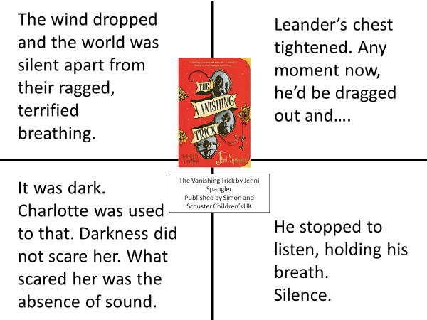 | Read multiple texts that use the same technique to understand its effect and how to use it in different contexts or to consider how authors choose words and build images:  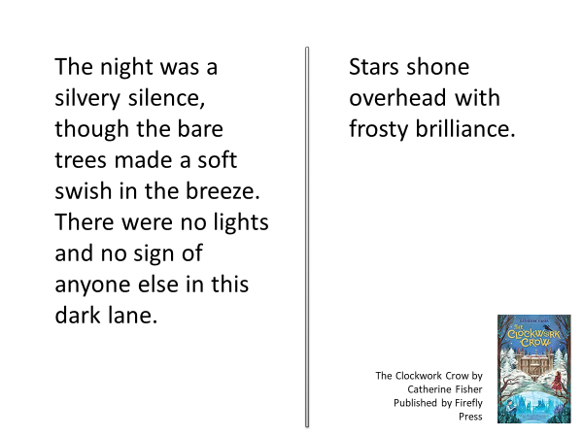  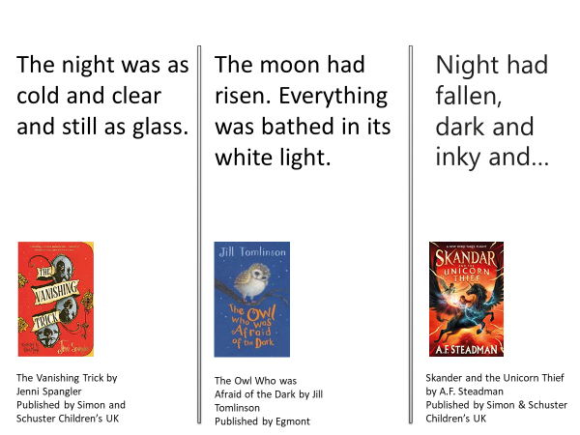
Overwriting – using the structure of the original text and changing words to explore different effects  e.g., The gargoyles squat high on corners staring into space, their empty eyes unblinking until night comes. (Night of the Gargoyles by Eve Bunting)  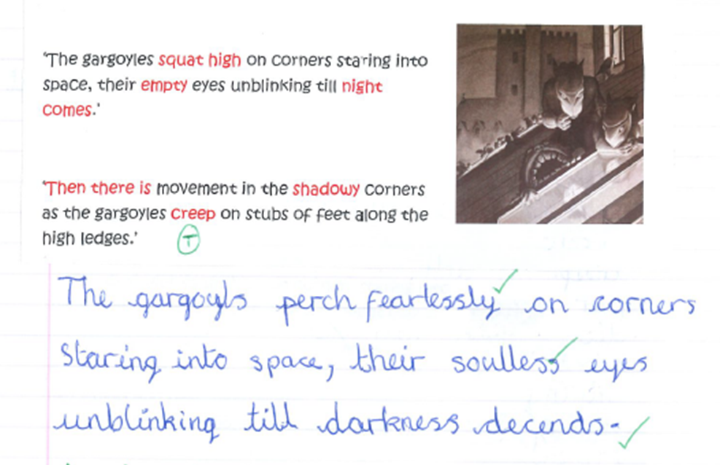 | Assimilate and integrate a sentence technique into their own writing e.g., story openings using double fronted adverbials:  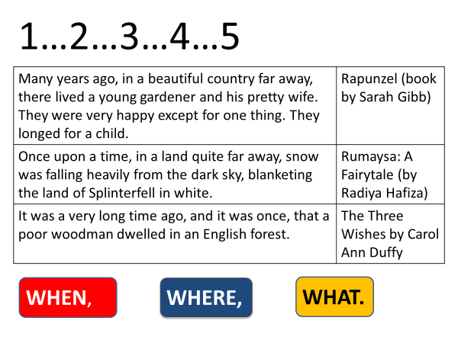  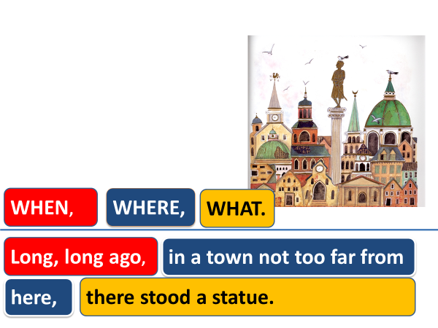

How our teachers develop children’s understanding of grammar rules and writing techniques

Retrieval Practice:  Previously taught grammar and writing techniques are regularly revisited and developed in line with National Curriculum expectations e.g., subordination is introduced in Year 2 and added to in each of the following years; similes are introduced in Year 3, and we continue to develop the children’s understanding and ability to create these through to Year 6.  When revisiting a writing tool, the teaching begins with retrieval practice:  - What do the children already know about…?  - When is it used? Why?  - Give an effective/less effective example  As well as strengthening memory for the children, this approach allows teachers to assess the starting point from which to take the teaching forward. | Scaffolding writing success: ‘I do…We do…You do…’  When introducing new grammar or a new writing technique, the learning is scaffolded to ensure children are guided to understand how, why, and when to apply effectively.  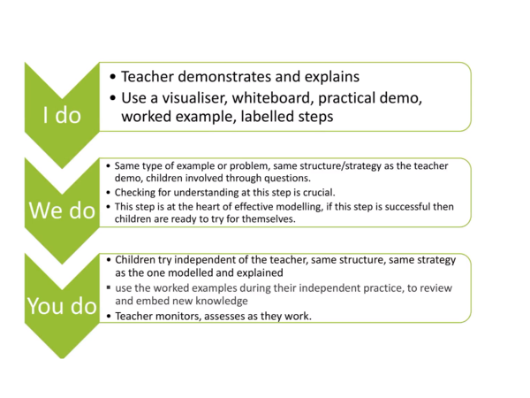  Assessment and feedback at step 2 (We do) is vital to ensure that children can successfully apply the technique into their own writing.
Worked examples:  Worked examples manage the cognitive load placed on working memory and allow children to focus their attention on the key feature, e.g., a punctuation rule. Freeing up space in the children’s working memories to focus on the punctuation rule means they are more likely to remember the rule and apply it correctly.  Teachers should construct worked examples with care and ensure that, in the beginning stages of learning a rule, the sentences that the children punctuate for themselves are closely matched to those in the worked example e.g.,  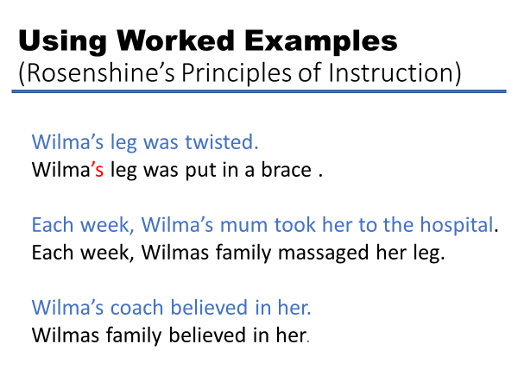  As confidence and understanding grow, the worked example is gradually withdrawn. The rate of the withdrawal may be different for different groups, depending on need. | Dictation:  We use dictation as an approach to practising punctuation and spelling rules. Short, regular dictation sessions are built in each week. The sentence length, type and complexity should be matched to the age group expectations.  Rationale  - We know that the complexity of writing can place a heavy load on working memory, especially for novices. Dictation is one approach that we use to reduce that cognitive load.  - Through explicit teaching and deliberate practice, children can develop and extend their ability to write proficiently.  - The short, focused nature of dictations allows teachers to provide specific feedback.

Exploring Vocabulary

A key aim of the writing curriculum at St Bede’s is to broaden and deepen the children’s vocabulary knowledge and understanding. When reading, new or unfamiliar vocabulary should be explained to children to aid comprehension, however more in-depth and explicit teaching of vocabulary is required. We will use the model given by Beck et al (2013) who identify the 3 tiers of vocabulary:
- Tier 1 – words used in everyday conversation.
- Tier 2 – words that come up infrequently in conversations and can be used across a range of circumstances, subjects, and situations (domains).
- Tier 3 - subject specific vocabulary.

When introducing a new unit and text, the teacher will select a group of Tier 2 words to specifically teach to the children. For younger age groups or simpler texts, these words may not actually appear in the text but may be related to it. The following process for teaching new vocabulary will be followed:

- Read the text.
- Identify the word to be taught. Say it and ask the children to say it aloud to help build their memory for the sound and meaning of the word.
- Give a pupil-friendly definition of the word.
- Engage the children in activities that develop a deep understanding of the word in a variety of contexts. These should take place over several days so that the children’s understanding and knowledge of the word becomes embedded.
- Use the words in a stem sentence or apply it to their own experience.
- Children say the word again to reinforce its phonological representation and meaning by answering comprehension style questions.

Beck et al also suggest a range of methods of encouraging children to interact with words:

- Questions, Reasons and Examples – if you are walking around a dark room, you need to do it cautiously. Why? What are some of the other things that need to be done cautiously? What is something you could do to impress your teacher? Why? Which of these things might be extraordinary? Why/why not?
  - a shirt that was comfortable, or a shirt that washed itself.
  - A flower that kept blooming all year, or a flower that bloomed for three days.
  - A person who has a library card, or a person who has read all the books in the library.
- Making Choices – if any of the things I say might be examples of people clutching something, say ‘clutching’. If not, do not say anything
  - Holding on tightly to a purse.
  - Holding a fistful of money.
  - Softly petting a cat’s fur.
  - Holding on to branches when climbing a tree.
  - Blowing bubbles and trying to catch them.
- Relating Words – Using target words in a single sentence or asking children to choose between target words (if you get your clothes ready to wear to school before you go to sleep, would that be sensible or raucous?)
- One Context of All the Words – Use a single context to relate different words:
  - What would an immense plate of spaghetti look like?
  - Why might you feel miserable after eating all that spaghetti?
  - What would it look like to eat spaghetti in a leisurely way?


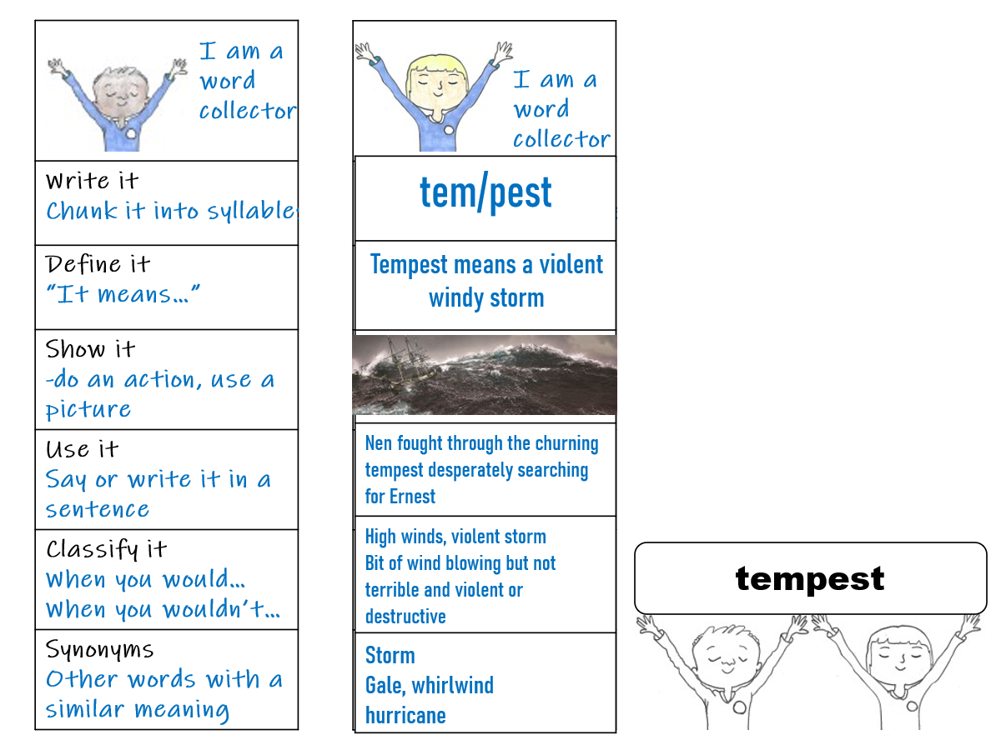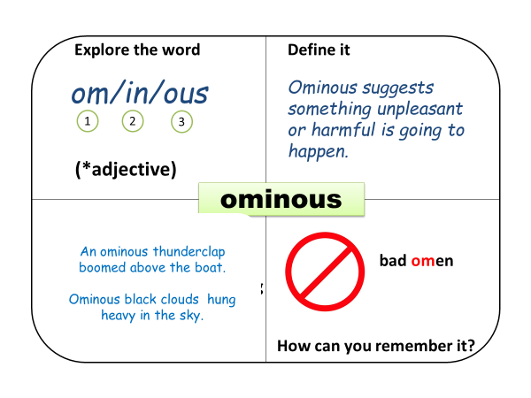
Other ways to develop vocabulary:
- Dual coding can be used to aid word meaning as the images may result in more connections being made due to prior knowledge, aiding understanding.
- Graphic organisers can be used to explore the words in depth.
- Questioning should be used to draw out a deeper understanding of the words taught.

We also aim to broaden children’s vocabulary by focusing on author’s vocabulary choice as children read and discuss the core text and as they plan vocabulary to use in their own writing.

Research tells us that children need between four and ten exposures to a new word before they will remember it. Therefore, teachers will deliberately plan to revisit vocabulary already learned e.g., once new words have been taught, teachers should deliberately plan to use the word in conversations and teaching sessions in a variety of different contexts. Retrieval practice can also be used as a method of revisiting previously taught vocabulary e.g., games and quizzes at the end of a day, later in the week, later in the half term and at the end of the term or school year.

Spelling
Manipulation of sounds and the development of oral language skills begin in Nursery, where children are exposed to a wide variety of rhyming, rhythmic and alliterative activities, building up to the skills of oral blending and segmenting. From Nursery and into Key Stage 1, the school follows the Essential Letters and Sounds systematic synthetic phonics scheme. Through this scheme, children are taught to read quickly and manipulate letters and sounds to spell an increasing variety of vocabulary confidently and independently. Children are engaged in phonics activities daily, from Nursery to Year 1, for 30 minutes. Children are also given spellings from the common exception word lists, to ensure rapid recall of words necessary to maintain fluent, confident, and accurate writing compositions. In Year 2, as the children become proficient at phase 5 phonics, they are engaged in the Essential Spelling scheme, which is a systematic and rigorous approach to teaching spelling at phase 6. As the children progress into Key Stage 2, children will be encouraged to: proof-read their work for spelling errors; recognise and used word origins, families, and roots to build their skills; and use dictionaries and thesauruses to develop their vocabulary. The children will also be taught how to spell words from the National Curriculum Year 3-4 and 5-6 word lists.

Grammar, Punctuation and Vocabulary
Grammar, punctuation, and vocabulary skills are taught explicitly as part of writing lessons and the children are given the opportunity to identify how authors have used such devices effectively. Grammar and punctuation are planned and taught using the 2014 National Curriculum year group expectations and children are expected to apply their knowledge consistently and cumulatively in their writing (Appendix 5).

Impact

Teachers use assessment as an integral part of the teaching and learning process and link it clearly to the children’s next steps. Success criteria is shared with and, when appropriate, created by the children, to support the writing process. Teachers record and track each child’s progress using the Writing Framework checklists for each year group (Appendix 6). After each unit of teaching, a piece of work is assessed according to this criteria and levels given (working towards the expected standard, working within the expected standard, working at greater depth within the expected standard). Six pieces of work per year are assessed in this way and all staff are involved in moderation exercises to ensure rigorous and reliable judgements.

We intend the impact on our children to be that they will have the knowledge and skills to be able to write successfully for a purpose and audience. With the implementation of the writing sequence being established and taught in all key stages, children will become more confident writers and will be able to plan, draft and edit their own work. By the end of Key Stage 2, children will have developed a writer’s craft, will enjoy sustained writing and will be able to manipulate language, grammar, and punctuation effectively. As all aspects of English are an integral part of the curriculum, cross-curricular writing standards will improve and skills taught in the English lesson will be transferred into other subjects, showing consolidation of skills and a deeper understanding of how and when to use specific devices effectively.

Appendix 1: Reading Pillar
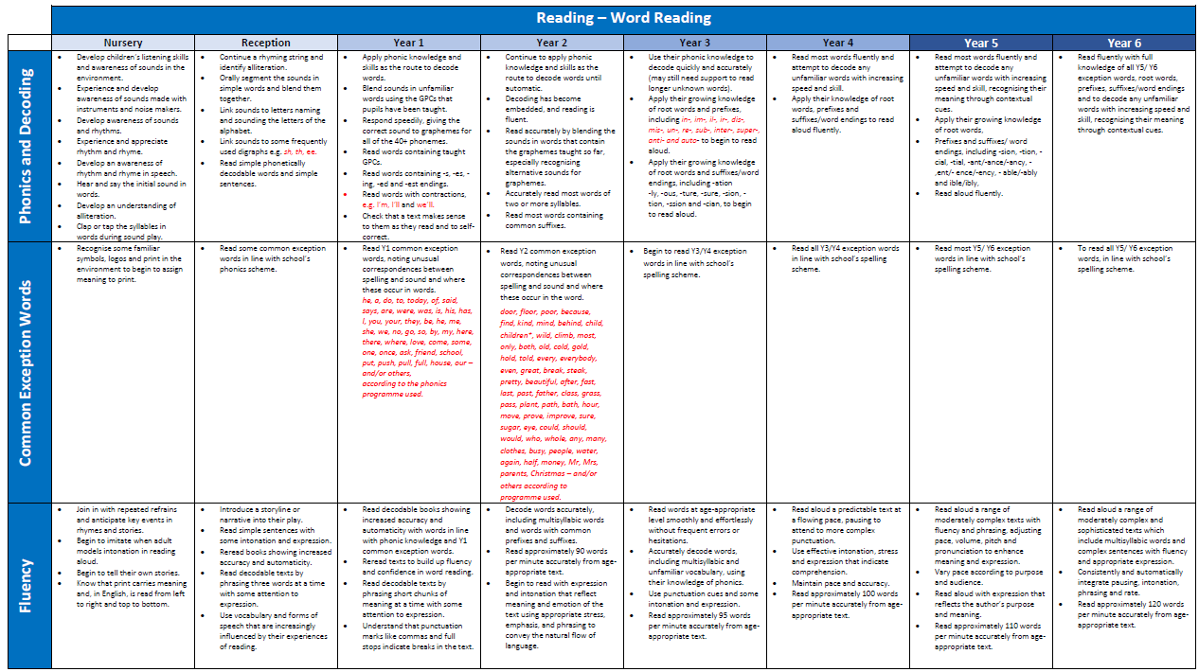

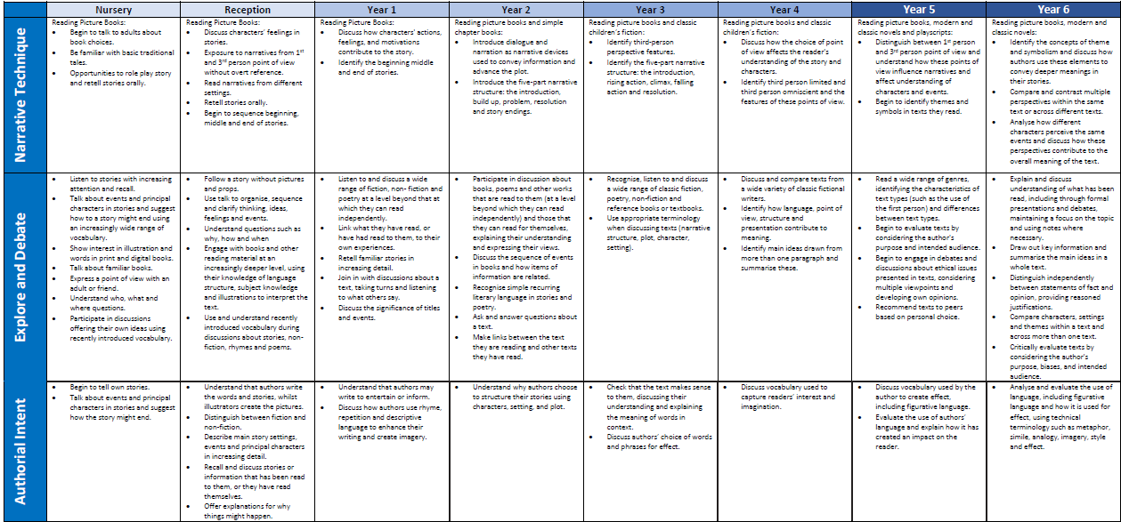

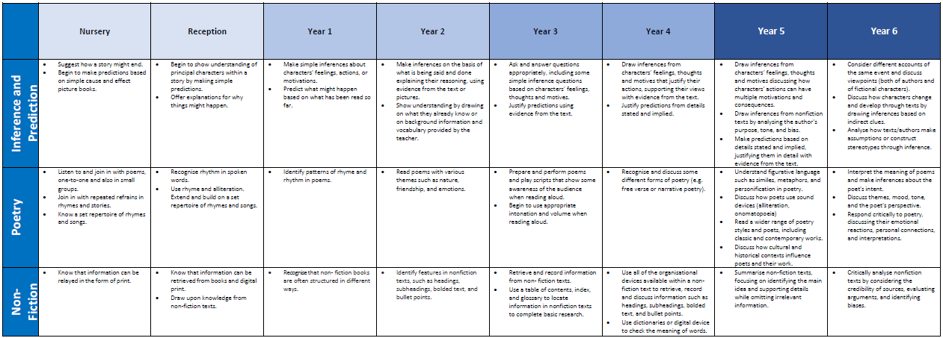

Appendix 2: Writing Pillar

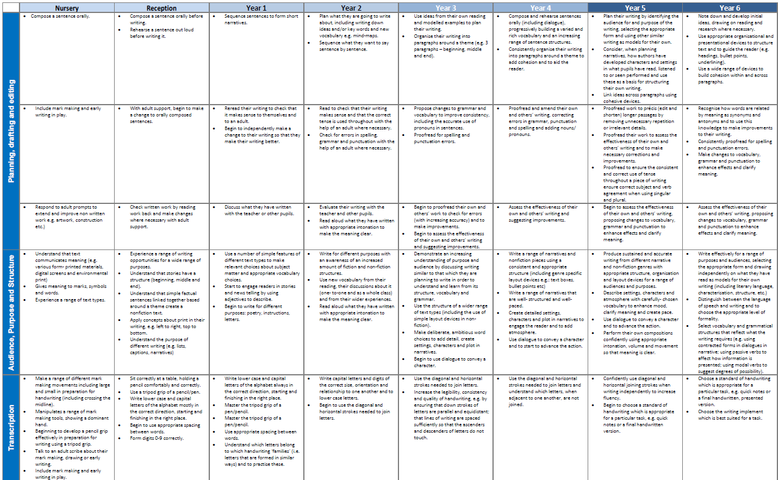
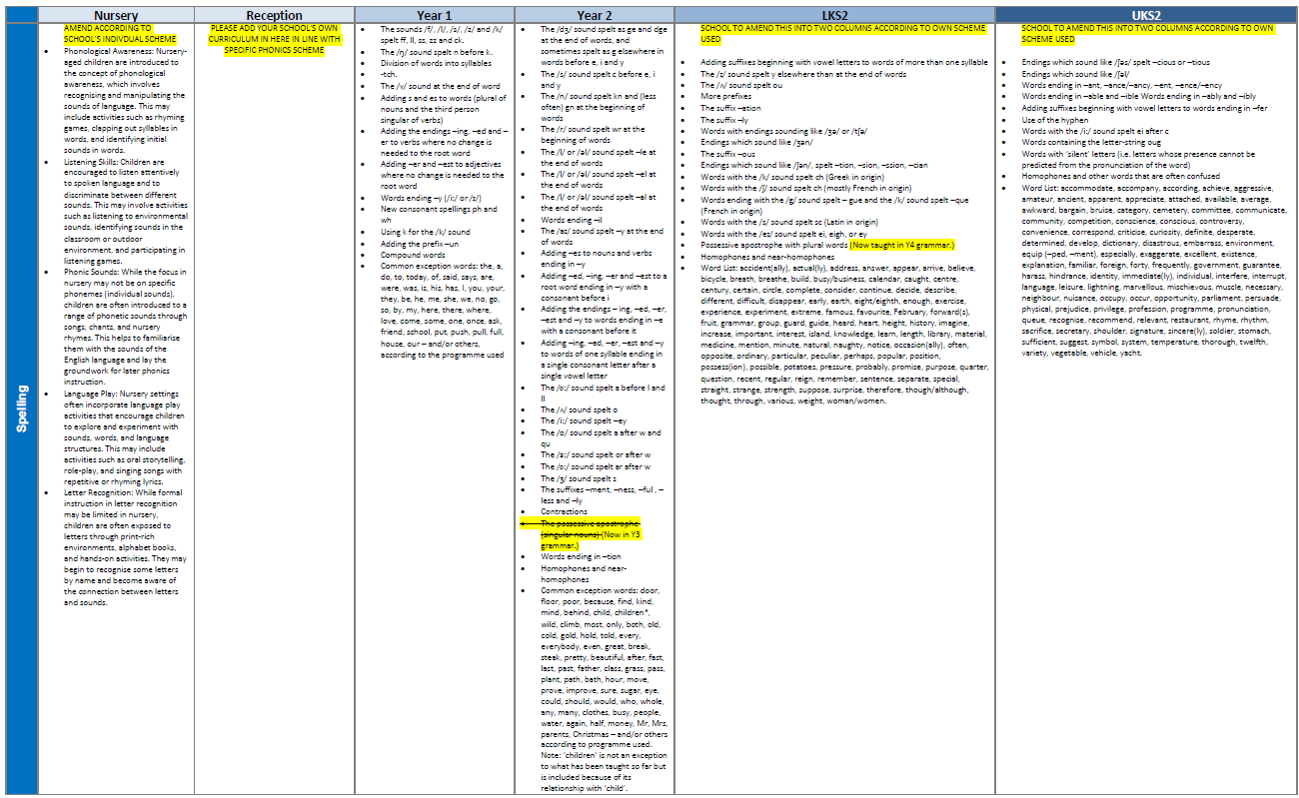

Appendix 3: Grammar Pillar

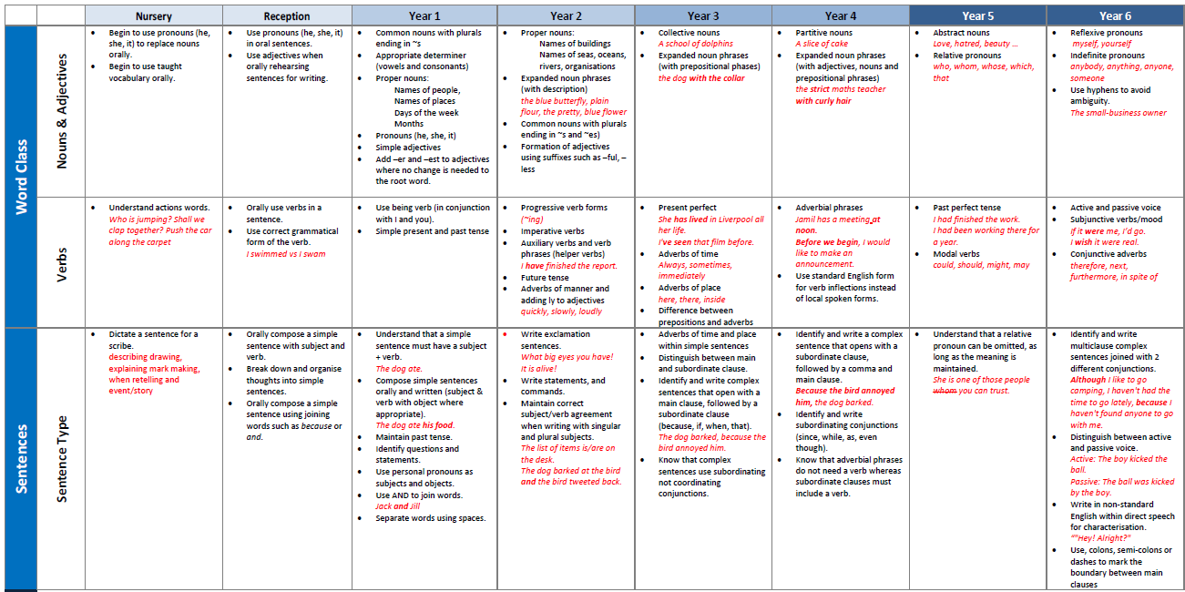

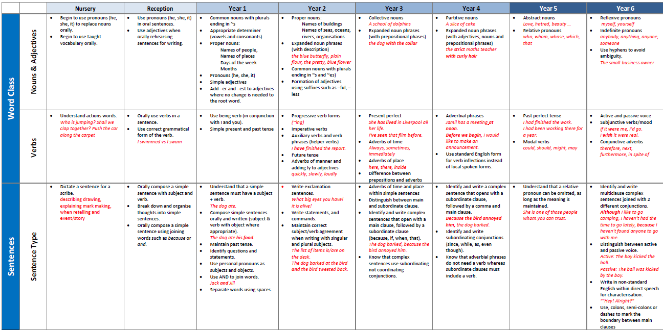

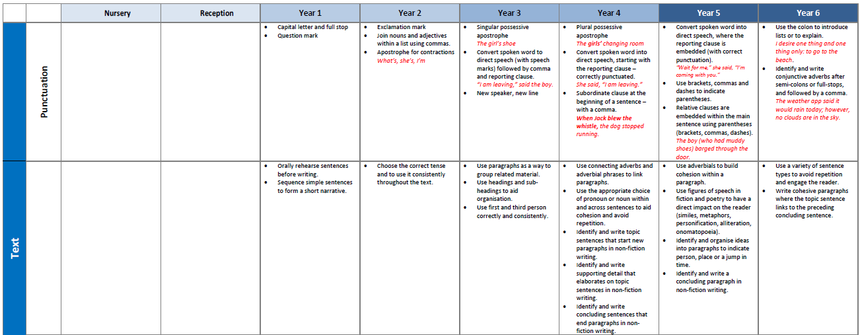

Appendix 4: Oracy Pillar

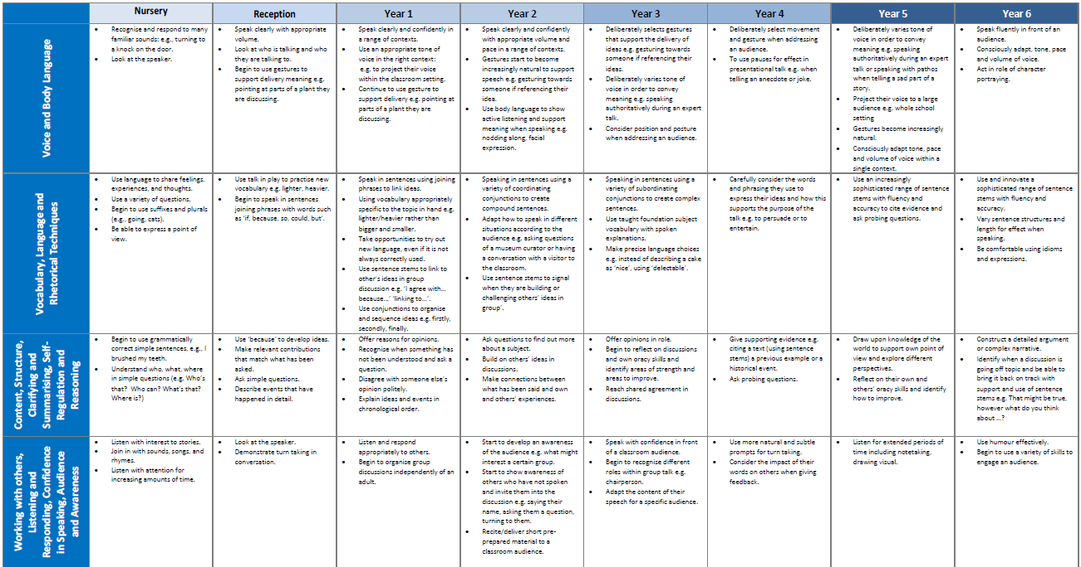

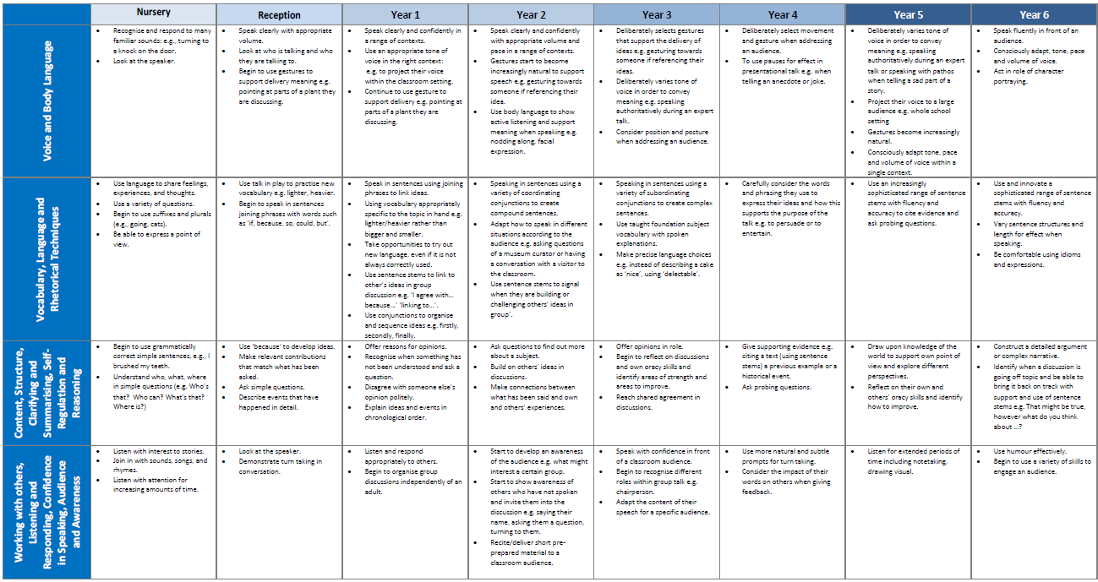

Appendix 5: Statutory Vocabulary, Grammar, and Punctuation from the English National Curriculum 2014
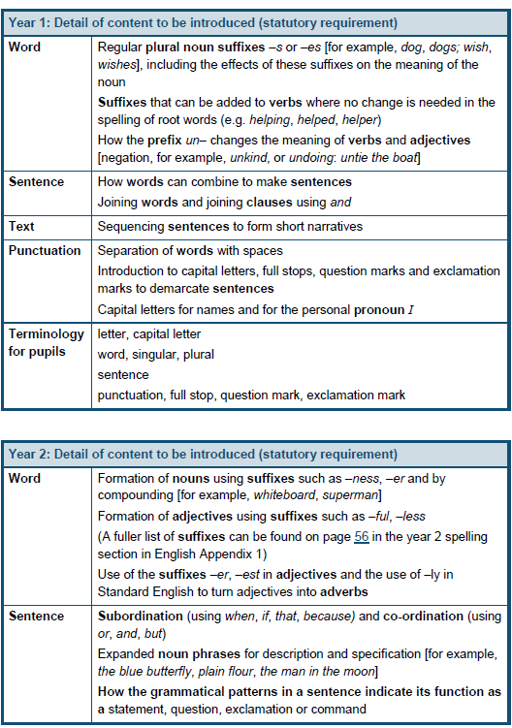 | 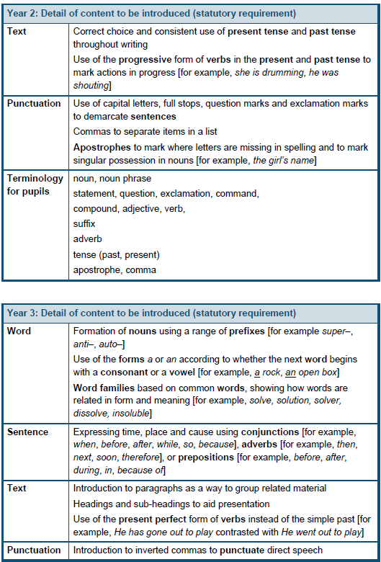
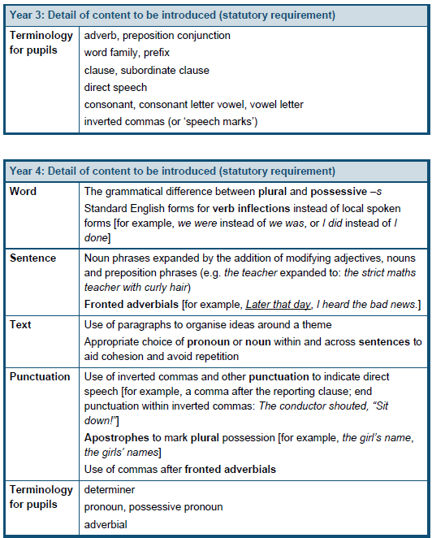 | 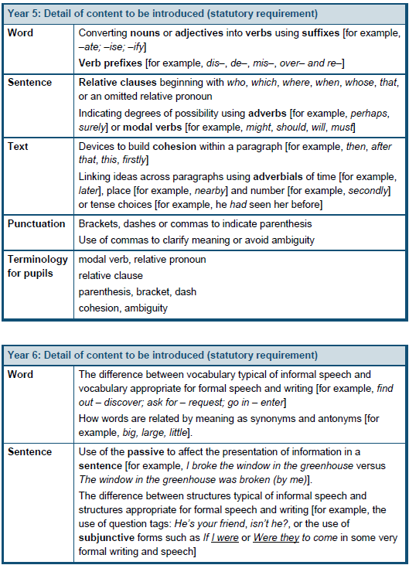
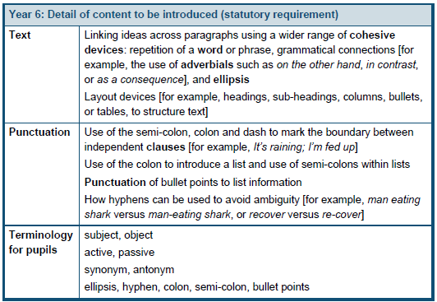

Appendix 6: Writing Assessment Frameworks
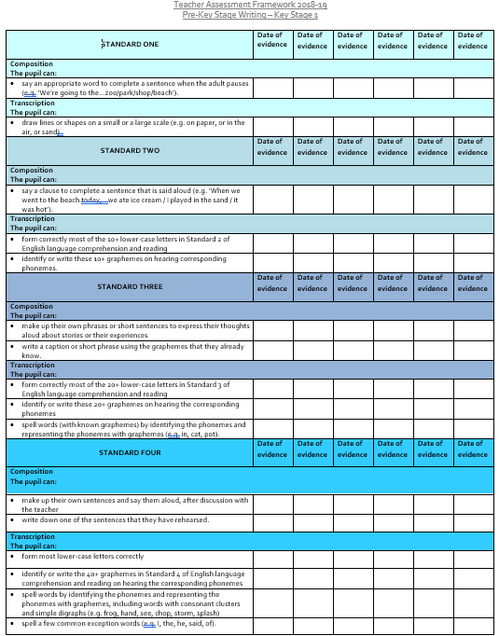 | 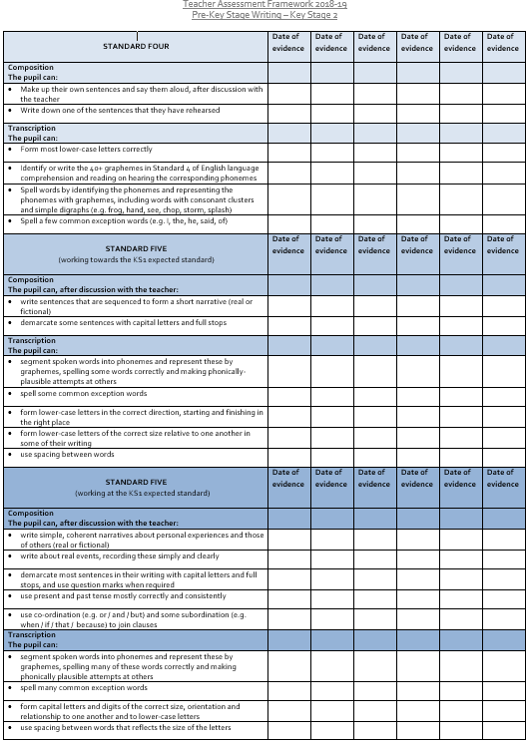
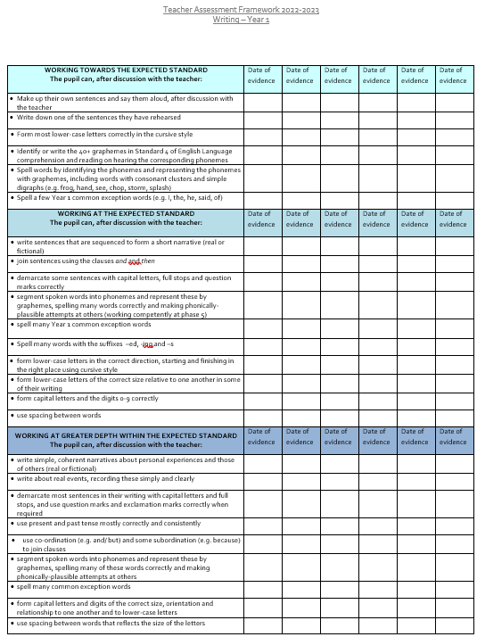 | 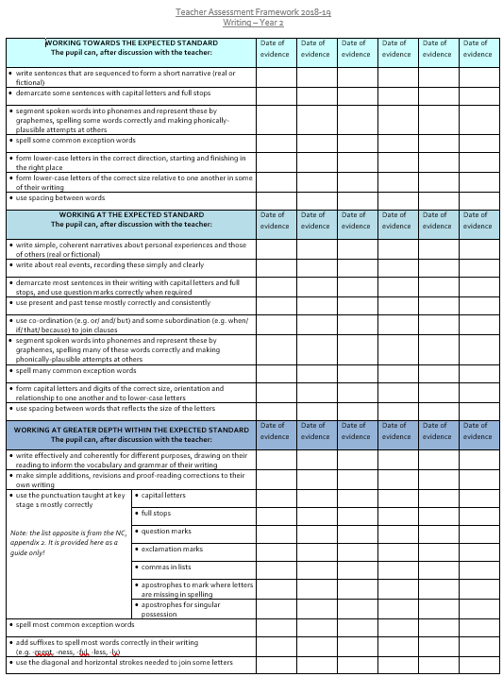

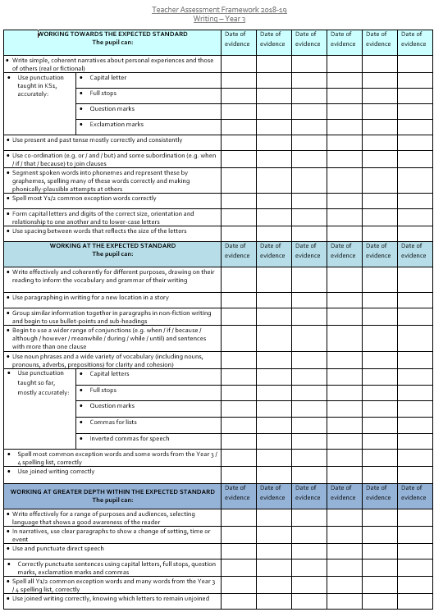 | 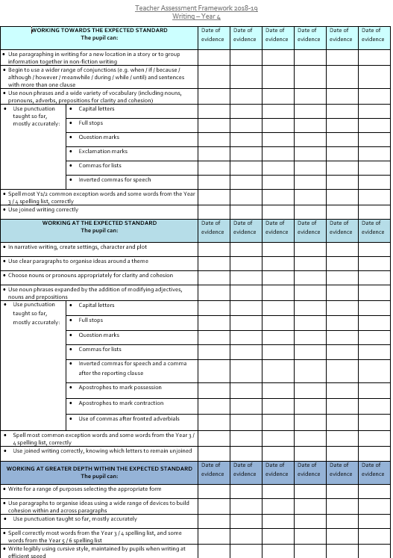
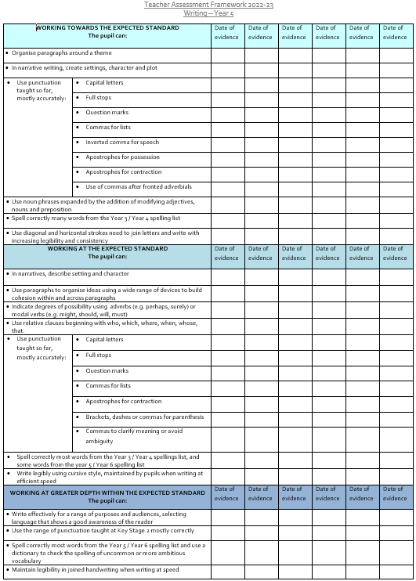 | 