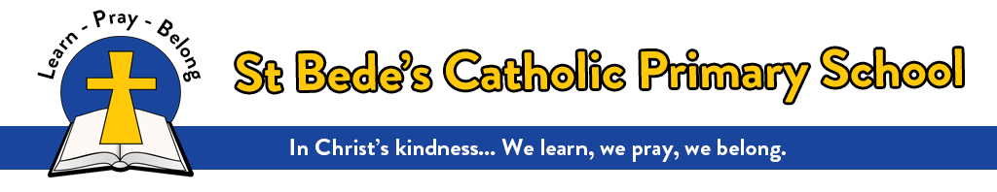

Reading Curriculum Intent, Implementation and Impact

Statement of Intent
At St Bede’s Catholic Primary School, we believe that the teaching of reading is integral to a child’s understanding and appreciation of the world around them. It is a platform that allows our children to see beyond what they know; to share in cultural experiences; and to develop the vocabulary they need to effectively express themselves. Our reading curriculum strives to foster a lifelong love of reading by cultivating positive reading behaviours based on frequent reading activities, that focus on both teaching key reading skills as well as developing reading for pleasure.

This curriculum is delivered initially through systematic synthetic phonics teaching in the Early Years and Key Stage 1, using the Essential Letters and Sounds teaching scheme. This scheme is directly linked to phonically based home readers, guided reading books and digital resources such as the Essential Letters and Sounds e-Library, all of which are used to ensure a consistent and persistent approach to teaching our youngest children to read quickly and successfully.

The teaching of reading progresses throughout Key Stage 1 and into Key Stage 2 with a strong emphasis on reading in the teaching of English. The reading curriculum is entirely linked to the writing curriculum and children are taught key reading skills using high quality and challenging texts. Reading takes place daily and children are encouraged to read for pleasure through the use of well-stocked classroom book areas and the school library. All children are assessed termly and placed within book bands so that the books they take home to read are directly linked to their current reading levels. Children are given opportunities to hear quality texts read aloud on a regular basis, from EYFS to Year 6. Furthermore, in Key Stage 2, our Year 4, 5 and 6 children use Reading Plus, an online reading platform, three times per week. This platform allows the children to read engaging and accessible texts at a level appropriate to their reading ability, as well as developing their vocabulary and comprehension skills. Reading Plus can also be accessed at home. All of these are essential components that offer the range of opportunities needed to develop fluent, enthusiastic, and critical readers.

It is important that children are motivated to read at home regularly; when their reading opportunities increase, so does their fluency and stamina which in turn increases their enjoyment of reading. Therefore, the link between children’s motivation to read and reading for pleasure is reciprocal. Furthermore, we know that reading for pleasure is beneficial not only for improved reading outcomes but for wider learning enjoyment and mental wellbeing. Thus, we work hard to foster a love of independent reading and build communities of engaged readers. We understand the significance of parents and carers in supporting their children to develop both word reading and comprehension skills, so we endeavour to build a home-reading partnership which enables parents and carers to have the confidence to support their children with reading at home.

Reading is at the very heart of our curriculum. We are committed to promoting a love for reading and not only giving children opportunities to read in English lessons, but in the wider curriculum too.

Implementation
Early Reading and Phonics
Learning to read is one of the most important things a child will ever learn. It underpins everything else, so we put as much energy as we possibly can into making sure that every single child learns to read as quickly as possible. We want our children to develop a real love of reading and to want to read for themselves.

We start by teaching phonics in Nursery, using the Essential Letters and Sounds for Nursery scheme. This focuses on phase 1 elements of: environmental sounds, instrumental sounds, body percussion sounds, rhythm and rhyme, alliteration, voice sounds and oral blending. Children are taught in a mixture of small, focused groups and whole class sessions, which last approximately 10 minutes per day. Sessions begin from the children’s first days in nursery and by Spring Term, children are being introduced to phase 2 GPCs so that by the end of their nursery year, the children will have experienced all single letter sounds and will be beginning to blend CVC words orally. As children move on to Reception, they are taught blending and segmenting via the Essential Letters and Sounds systematic synthetic phonics scheme. The principles of this scheme are as follows:

- The delivery of whole-class, high-quality first teaching with well-structured daily lesson plans
- The use of consistent terminology by teachers, children and parents
- The use of consistent resources that support effective teaching
- Repetition and reinforcement of learning
- Regular and manageable assessment to ensure that all children ‘keep up’ rather than ‘catch up’
- The ‘E’ model (focusing on ongoing, whole-school training and support for all staff)
(Essential Letters and Sounds Handbook 2021, p4)

These principles are adhered to throughout the EYFS and Key Stage 1, where children in Year 1 and 2 are also taught via this approach. Phonics takes place daily for 30 minutes. Interventions are implemented during phonics lessons by teachers or teaching assistants, with a focus on ensuring that all children ‘keep up’ rather than ‘catch up’. Children are also taught ‘Harder to Read and Spell Words’ (HRSW) on sight to enable them to read fluently and independently as soon as possible. As children move on to Year 2, they receive 3 spelling lessons per week based on the ELS Essential Spelling Scheme which seeks to support children’s ability to ‘encode with success’ and to ‘know, recognise and understand which sounds are represented by which spellings.’ (Essential Spelling Handbook, p.6). The approach used, directly follows on from the ELS phonics scheme and incorporates consistent use of terminology and resources with which the children are already familiar. This helps to embed learning in EYFS and Y1 and develops the children’s reading skills so that they can move on to read for understanding. Children’s fluency in reading becomes a focus in Year 2 and children are given opportunities to engage in whole class reading sessions as part of their daily English curriculum. Through strategies such as Reader’s Theatre, Choral Reading and Echo Reading, children are given opportunities to hear skilled adult readers reading aloud and then to apply these skills in their own reading.

Early reading books are fully phonically decodable and link directly to the Essential Letters and Sounds phonics scheme. Similarly, regular guided reading sessions, led by class teachers or teaching assistants, focus on consolidation and practise of grapheme-phoneme correspondences taught in phonics sessions within each year group. Teachers regularly read with the children, so they get to know and love all sorts of stories, poetry and information books. This helps to extend the children’s vocabulary and comprehension, as well as supporting their writing. All classrooms have attractive and well-stocked book corners, where the children can access a wide range of books (both fiction and non-fiction) to help embed their love of reading. Children also have access to an EYFS/Key Stage 1 library, that contains a wider range of reading material, which they can take home and share with parents and carers.

At St Bede’s, we follow the Bishop Wilkinson Catholic Education Trust’s English curriculum. A main pillar of this curriculum is reading and as part of that pillar, children in EYFS and Year 1 are exposed to a Traditional Tales and Poetry Canon. Teacher’s and Teaching Assistants read daily to the children using texts from this Canon. With daily exposure during these reading sessions, the children become very familiar with these key texts and story structures which will support their reading and writing as they move through the school. The texts are available in the class libraries for the children to access independently.

EYFS Poetry Canon
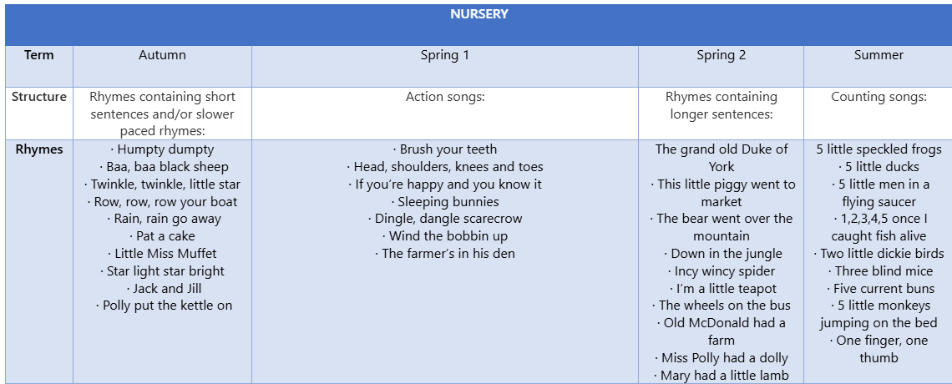

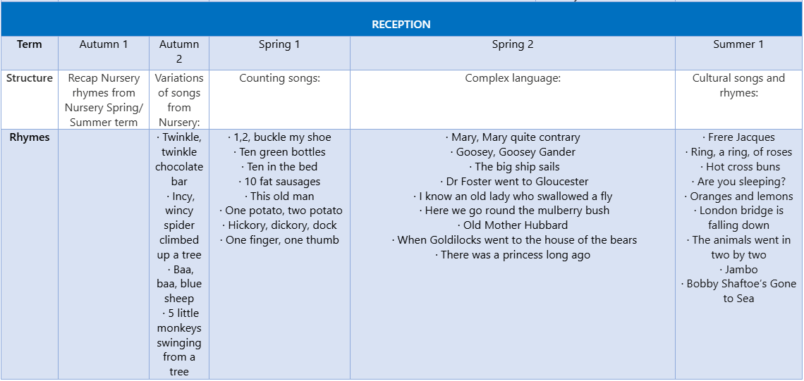

EYFS Traditional Tales Canon
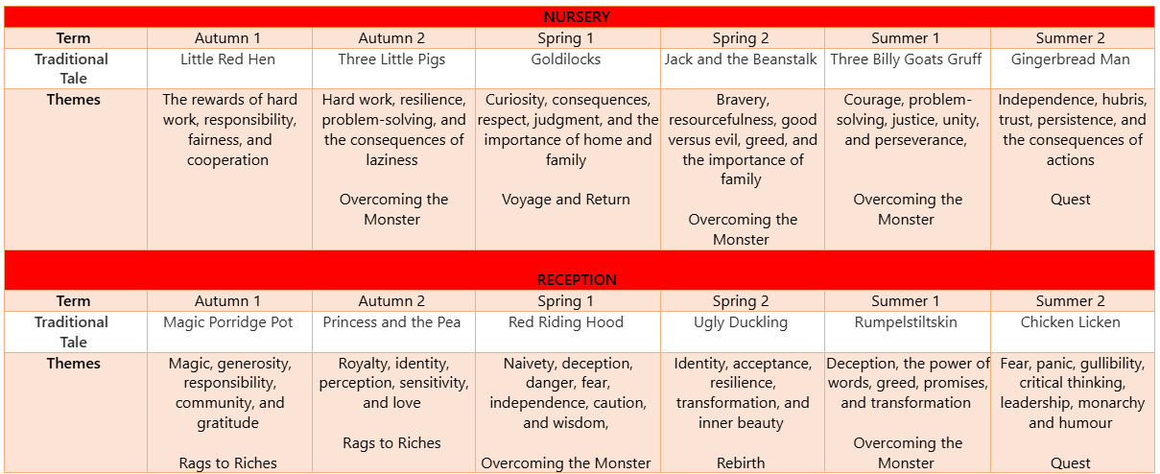
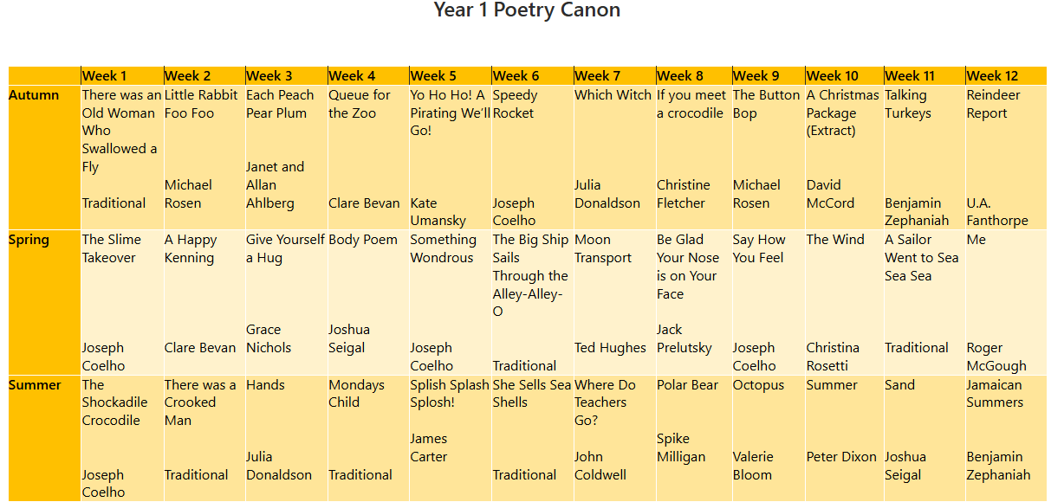

Reading in Key Stage 1 and 2
As children become more fluent readers, their need for regular phonics teaching decreases, so that by the time they reach the end of Year 2, the daily phonics lesson changes to have more of a focus on spelling patterns and rules. Reading is largely taught through the daily English lesson, which focuses on a wide variety of high-quality texts, encompassing fiction, non-fiction and poetry genres. Key comprehension skills are taught in whole class lessons and, in Year 4-6, regular Reading Plus reading sessions. Regular assessment is key in ensuring that children are making good progress and that any gaps in knowledge and skills are being met.

Impact
Early Reading and Phonics
Children’s progress in phonics is continually reviewed every 5 weeks through phonic assessments (using Phonics Tracker) and evidence from their reading and writing. Through this formative assessment, teachers identify the gaps in knowledge that need to be addressed through targeted interventions. In June, the national Phonics Screening Check is undertaken to confirm that the children have learned to decode to an age-appropriate standard and determines what level of provision they will require the following year.

Key Stage 1 and 2
In Year 2-6, regular assessment of the children’s decoding and comprehension is undertaken through PiRA assessments and the assessment of individual readers using age-related fluency tests which help to give a reading rate and identify those children who require further intervention. Further to this we use the York Assessment of Reading for Comprehension to identify areas of challenge for struggling readers and plan appropriate interventions using quality first teaching or small group reading support led by Teaching Assistants.

The reading book bands are as follows:

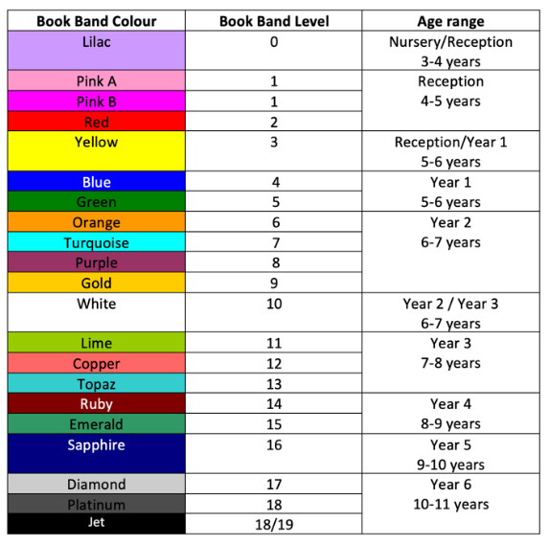

Book band levels are reviewed each term, taking into consideration termly data. Further information about children’s standards in reading is gleaned from SATs scores, reading journals and notes from guided reading sessions. All are used to triangulate where each individual child is on their reading journey.

Phonics Curriculum Overview (Essential Letters and Sounds)
Nursery | Reception | Year 1 | Year 2
Phase 1  Aspect 1 – General sound discrimination – environmental sounds  - To develop children’s listening skills and awareness of sounds in the environment.  - Further development of vocabulary and children’s identification and recollection of the difference between sounds.  - To make up simple sentences and talk in greater details about sounds.  Aspect 2 – General sound discrimination – instrumental sounds  - To experience and develop awareness of sounds made with instruments and noise makers.  - To listen to and appreciate the difference between sounds made with instruments.  - To use a wide vocabulary to talk about the sounds instruments make.  Aspect 3 – General sound discrimination – body percussion  - To develop awareness of sounds and rhythms.  - To distinguish between sounds and to remember patterns of sound  - To talk about sounds we make with our bodies and what the sounds mean.  Aspect 4 – Rhythm and rhyme  - To experience and appreciate rhythm and rhyme and to develop awareness of rhythm and rhyme in speech.  - To increase awareness of words that rhyme and develop knowledge about rhyme.  - To talk about words that rhyme and to produce rhyming words.  Aspect 5 – Alliteration  - To develop understanding of alliteration.  - To listen to sounds at the beginning of words and hear the differences between them.  - To explore how different sounds are articulated, and to extend understanding of alliteration.  Aspect 6 – Voice sounds  - To distinguish between the differences in vocal sounds, including oral blending and segmenting.  - To explore speech sounds.  - To talk about the different sounds that we can make with our voices.  Aspect 7 – Oral blending and segmenting  - To develop oral blending and segmenting of sounds in words.  - To listen to phonemes within words and to remember them in the order in which they occur.  - To talk about the different phonemes that make up words. | Some aspects of phase 1 may be revisited in the early stages of Reception  Phase 2 (Autumn 1)  - Oral blending  - Sounding out and blending with 23 new grapheme-phoneme correspondences (GPCs)  - 12 new harder to read and spell words (HRS)  - s, a, t, p  - i, n, m, d and I, the, no  - g, o, c, k and put, of, is  - ck, e, u, r and to, go, into  - ss and pull Assess and review week R:1  - h, b, ff, ll and as, his  - j, v, w, x and he, she, buses  - y, zz, qu, ch and we, me, be  - sh, th, ng, nk and push  - ai, ee, igh, oa and was, her  - -es (where there is no change to the root word) Assess and review week R:2  - Assess and review week R:3 and my, you  Phase 3 (Autumn 2, Spring 1 & 2)  - Oral blending  - Sounding out and blending with 29 new GPCs  - 32 new HRS words  - Revision of phase 2  - Assess and review week R:4 oo (look)  - ar, ur, oo (food), or and they, all, are  - ow, oi, ear, air  - ure, er, ow and ball, tall  - Assess and review week R:5 and when, what  - Assess and review week R:6  - Assess and review week R:7 and said, so, have  - Assess and review week R:8 and were, out, like  - Assess and review week R:9 and some, come, there  - Assess and review week R:10 and little, one, do  - Assess and review week R:11 and children, love  - Assess and review week R:12  Phase 4 (Summer 1)  - Oral blending  - No new GPCs  - No new HRS words  - Word structures – CVCC, CCVC, CCVCC, CCCVC, CCCVCC  - Suffixes  - Revision of phase 2 and phase 3  - CVCC and -ed  - CCVC and -ed  - CCVCC and -ed  - CCCVC  - Assess and review week R:13  - CCCVCC and -er, -est  Phase 5 including alternative and lesser-known GPCs (Summer 2)  - Introduction to phase 5 for reading  - 20 new GPCs  - 16 new HRS  - ay, ou, ie, ea, -le and oh their  - ou, ir, ue, aw and people, Mr, Mrs  - wh, ph, ew, oe and your, ask, should  - or, ey, a_e, e_e and would, could, asked  - Assess and review week R:14 and house, mouse, water  - i_e, o_e, u_e, c and want, very | Some aspects of Phase 4 may need to be revisited in the early stages of Year 1  Phase 5 including alternative and lesser-known GPCs (Autumn 1 and 2)  - Revision of previously taught phase 5 GPCs  - 2 new GPCs  - 9 new HRS words  - Assess and review week Y1:1  - Assess and review week Y1:2  - Revise ay, ou, ie, ,ea  - Revise ou, ir, ue, aw  - Assess and review week Y1:3  - Revise wh, ph, ew, oe  - Revise au, ey, a_e, e_e and please, once  - Revise i_e, o_e, u_e, c and any, many, again  - y, al (walk) Assess and review week Y1:4 and who, whole  - Assess and review week Y1:5 and where, two  - Assess and review week Y1:6  - Assess and review week Y1:7  Phase 5 (Spring 1 and 2)  - Alternative spellings for previously taught sounds  - 49 new GPCs  - 4 new HRS words  - Oral blending  - Revision of phase 2, phase 3 and phase 4  - Assess and review week Y1:8  - a (acorn), ey (they), ea (great), eigh (weight), a (father), e (he), i (find), y (by)  - o (go), a (was), u (push), u (music), ch (school), ch (chef), ea (head) and here, sugar, friend  - or (world), ear (learn), ou (soup), ou (shoulder), ie (brief), ve (have), y (gym) and because  - Assess and review week Y1:9  - are (care), ere (there), ear (pear), tch (catch)  - o (brother) Assess and review week Y1:10  - g (gem), ge (fringe), dge (bridge), st (listen)  - ce (fence), se (house), gn (sign), kn (knee), wr (wrap), mb (lamb)  - se (cheese), ze (freeze), eer (cheer), ere (here), ti (patient), tion (station)  - Assess and review week Y1:11  - al (half), augh (caught), ssi (session), si (vision), tious (scrumptious), ci (delicious), -ous, -ion, -ian  Beyond Phase 5  - Continue to make links between GPC knowledge and spelling  - Revision of all previously taught GPCs for reading and spelling  - Wider reading, writing and spelling curriculum  - Teach rarely-used GPCs: sc (science), bt (doubt), y (crystal), u (busy), ne (gone), mn (column), gh (ghastly), gu (guard), ou (cough), ou (tough), oo (flood), wh (whole), gh (rough), u (penguin), aigh (straight), ei (ceiling), i (police), eye (eyelash), is (island), uy (buy), ough (dough), eau (plateau), ear (heart), our (colour), re (centre), o (move), ou (group), ui (juice), oe (shoe), eau (beautiful), ar (warm), oar (roar), oor (floor), ore (more), ough (plough), ar (scary). | Some aspects of Phase 5 may need to be revisited in the early stages of Year 2.  Phase 6 (6-8 weeks)  Spelling  - Working on investigating and learning how to add suffixes:  - ing, ed, er, est, ful, ly, y, s, es.  - Introducing and teaching the past tense.  - Teaching spelling long words.  - Finding and learning the difficult bits in words.  - Consolidate automatic reading and spelling of graphemes with 2 or more letters.  - Develop routines and strategies for spelling.  Reading  - Children should know most of the common GPCs and be able to read hundreds of words by:  - reading familiar words automatically  - decoding words quickly and silently  - decoding words aloud  - During this phase children become fluent readers and increasingly accurate spellers.  - The shift from learning to read to reading to learn takes place and children read for information and for pleasure.  - The focus is on automatic recognition of graphemes consisting of 2 or more letters.  - Children should be encouraged to read aloud as well as silently for themselves.  - Children need to be taught to go beyond literal interpretation and recall, to explore the greater complexities of texts through inference and deduction.  - Children will develop self-regulated comprehension strategies:  - Activating prior knowledge  - Clarifying meanings – with a focus on vocabulary work  - Generating questions, interrogating the text  - Constructing mental images during reading  - Summarising  - Children should be taught to read fiction and non-fiction texts.  - Children should be taught to read poetry, exploring the effects of poetic language, continuing to develop their understanding rhythm, rhyme and alliteration.  - Children will be taught to read with phrasing and fluency and to take account of punctuation to aid meaning.  - Children will engage with and respond to texts; they will choose and justify their choice of texts and will begin to critically evaluate them.  - Children should listen to experienced readers read aloud and develop a love for reading.

Reading End Points
At St Bede’s we follow the Bishop Wilkinson Catholic Education Trust’s English curriculum, of which Reading is a key pillar. The end points for each year group are as follows:
